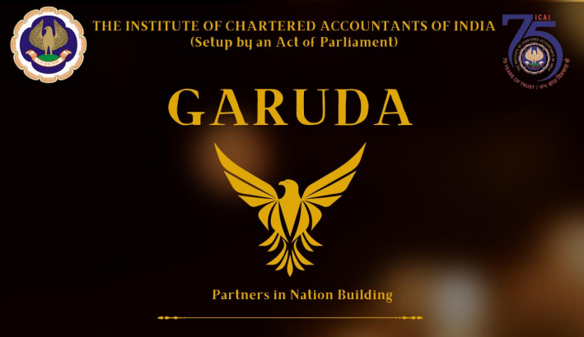

Contents

Contents
OFFICE BEARERS OF SICASA HYDERABAD 3
COMMUNICATION FROM SICASA CHAIRMAN 5
COMMUNICATION FROM SICASA CO-CHAIRMAN 6
FIVE MOST IMPORTANT SKILLS IN CORPORATE WORLD 8
STARTUP FINANCING AND VENTURE CAPITAL 9
PERSONAL FINANCE 11
DIGITAL RUPEE : BOON OR BANE 12
FINANCIAL TECHNOLOGY 14
CREATIVE CORNER 15

Disclaimer:
The Hyderabad Branch of SIRC or SICASA Hyderabad does not accept any responsibility for the views expressed by different contributors. The views and opinions expressed.in the articles are of the author and SICASA Hyderabad is not necessary to agree with the views.

OFFICE BEARERS OF SICASA HYDERABAD

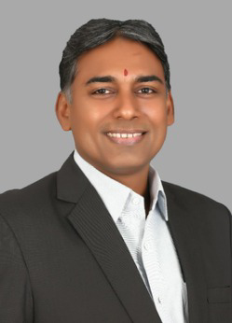
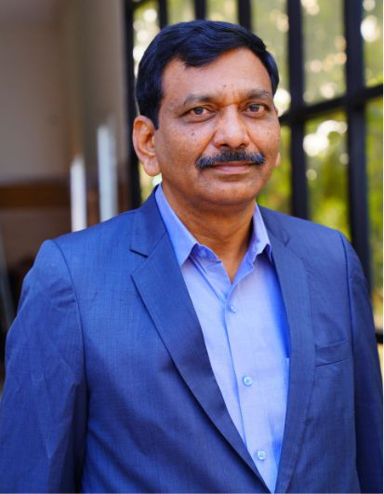

CA. Rama Rao Karumanchi
Chairman – SICASA Hyderabad
CA. Girdhari Lal Toshniwal
Co-Chairman–SICASA Hyderabad

Student Committee Members

Reach out for us:
Instagram: sicasa_hyd E-Mail: sicasahyderabad@outlook.com Telegram: sicasa_hyd_updates
Twitter: SICASAhyd WhatsApp: 6302783477 Facebook: sicasahyd

COMMUNICATION FROM SICASA CHAIRMAN

Dear students,
As we step into this new year, it brings me immense pleasure to extend my heartfelt greetings and warm wishes to each one of you. On behalf of the Hyderabad Branch of SICASA, I wish you a year filled with success, growth, and prosperity.
First and foremost, my heartfelt congratulations go out to all the diligent students who have successfully passed the CA examinations. Your hard work, dedication, and perseverance have borne fruit, marking a significant milestone in your professional journey. It is with great pleasure that I welcome all the CA Final students, as you have now become esteemed members of the ICAI. I would also like to extend my warmest congratulations to the CA Intermediate students on clearing their exams. I wish you all the very best as you embark on your practical training.
To those who faced challenges and might not have cleared the examinations this time, I urge you not to be disheartened. Remember, setbacks are merely steppingstones towards success. Use this experience as motivation to work harder, learn from the obstacles, and keep moving forward. Your determination and resilience will undoubtedly pave the way for your triumph in the future.
In conclusion, I encourage each one of you to stay focused, stay motivated, and continue your journey towards achieving your aspirations. Remember, success is not merely defined by the destination but also by the perseverance and dedication displayed throughout the journey.
As we embrace the festive spirit, I extend heartfelt wishes for a joyous Bhogi and a prosperous Makar Sankranti. May these festivities bring warmth, happiness, and abundant success to your lives.
Warm regards,
CA Rama Rao Karumanchi
Chairman
Hyderabad Branch of SICASA

COMMUNICATION FROM SICASA CO-CHAIRMAN

Dear students,
I extend my warmest congratulations to all the CA Final students on this remarkable achievement of becoming esteemed members of the ICAI. Your dedication, hard work, and commitment have led you to this significant milestone in your professional journey. Embracing this new chapter as members of the ICAI reflects your excellence and commitment to the field of finance and accounting. I am confident that you will continue to shine brightly in your future endeavours.
Additionally, I offer my heartfelt congratulations to the CA Intermediate students for successfully passing their examinations. As you embark on your practical training, my best wishes accompany you, embrace this period as an opportunity to gain hands-on expertise, as it will undoubtedly contribute significantly to your growth and success in your careers.
In the face of challenges, it's essential not to let disappointment overshadow your determination. To those who faced setbacks in the recent examinations, I urge you to embrace this moment as a catalyst for growth rather than allowing it to deter your spirits. Remember, failure is not the end but a bend in the road leading to success. Use this setback as an opportunity to learn, recalibrate your strategy, and forge ahead stronger than ever before. Believe in your abilities, trust your efforts, and remember that setbacks are temporary detours on the path to triumph. Stay dedicated, work hard, and success will undoubtedly grace your endeavours.
Wishing you strength, determination, and unwavering courage as you begin this renewed journey towards achieving your aspirations.
As we immerse ourselves in the joyful spirit of the season, I would like to extend my heartfelt wishes for a Happy Bhogi and Makar Sankranti celebration.
Be Happy - keep laughing!
Warm Regards,
CA. Girdhari Lal Toshniwal
Co-Chairman
Hyderabad Branch of SICASA
Branch Level National Talent Hunt
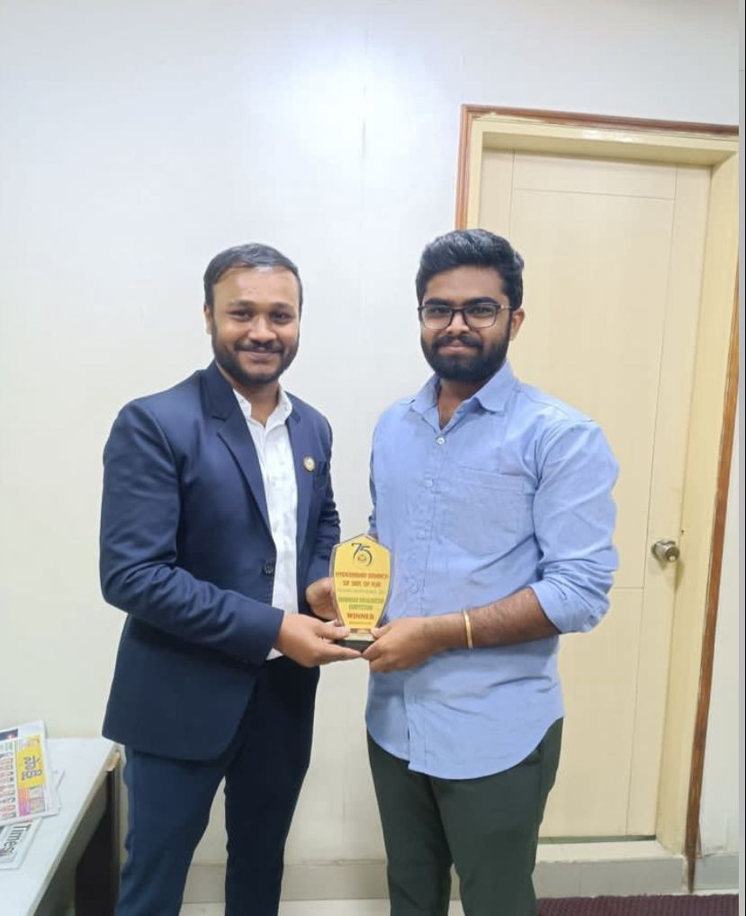
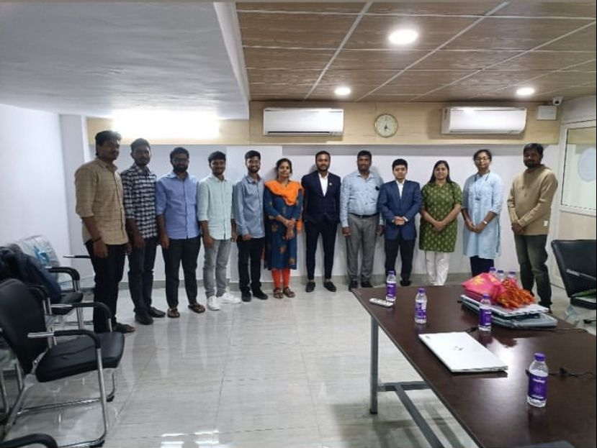

Aiming for AIR – Virtual Session with AIR 1 – Akshay Jain

FIVE MOST IMPORTANT SKILLS IN CORPORATE WORLD

An individual’s skill set determines to a considerable extent how successful they are going to be in their roles. These are the abilities that an individual must possess to be as an asset in the development of an organization. As much as technical skills, soft skills are equally important. Like they say ‘We grow through what we go through”, life teaches us skills as and when and it is on us to identify and learn from them.
Some of the essential skills in today’s corporate culture are:
Communication Skills- Communication transcends verbal expression. It encompasses both articulate speech and active listening. It deals with expressing thoughts and marketing ideas through words in a convincing way to others. Good communication skills facilitate in maintaining healthy relations with the clients. To be able to socialize and work as a team also requires robust communication skills.
Teamwork and Emotional Intelligence- Often when in a team, there are a group of people with different ideologies. All of them have to be put together and coordinated to emerge as a team. In such instances, it is on the part of the team members to be emotionally intelligent as everything cannot work according to their ideas and wishes alone. One should be aware of their emotions and responses to it, thereby facilitating an environment conducive to collaborative problem solving and creativity.
Problem Solving- Often formulation and implementation comes with many obstacles and to deal with it requires problem solving skills. One should be able to assist the organization in being reactive to the changing circumstances in the environment. Many a times the problem is not as big as it seems to be. Identifying that and coming up with solutions to cope with can prove to be advantageous to the organization.
Planning and Time Management- Time management and goal achievement go hand in hand. Since time waits for none, one has to know how to effectively manage resources for timely accomplishment of goals. To achieve this, working smarter than harder is the right thing to do. Deadlines are an inescapable part of the corporate culture. And in such a hustle culture, planning tasks and time helps to maintain a balance in life.
Creativity and Decision Making Skills - In this world where everyone is moving strategically, creativity helps in being relevant. Gathering different ideas and selecting the best one which could be a strategy is a huge decision which also requires critical thinking capabilities.
Mucharla Rithika - SRO0748615

STARTUP FINANCING AND VENTURE CAPITAL
In the world of entrepreneurship, securing adequate financing is one of the most important parts. Venture capital, a specialized form of funding, plays a crucial role in fuelling the growth and development of innovative businesses. This article will provide a simplified overview of start-up financing and explore the key aspects of venture capital.
Start-Up Financing:
Bootstrapping:
Start-ups often begin with bootstrapping, where founders use personal savings or revenue generated by the business to cover initial costs. This self-funding phase sets the groundwork for a sustainable foundation.
Friends and Family:
Another common source of early-stage funding is support from friends and family. While informal, these investments can provide the initial capital needed to get the business off the ground.
Angel Investors:
Angel investors are individuals who invest their funds in start- ups. Their involvement often goes beyond providing capital, as they may offer mentorship and guidance based on their industry experience.
Business Incubators:
A business incubator is a workspace created to offer start-ups and new ventures access to all the resources they need, all under one roof.
The above-mentioned are the few sources for start-up financing.
Venture Capital (VC):
Venture capital is a form of private equity financing thatinvestors provide to start-ups and small businesses with highgrowth potential. It can be viewed as a long-term investment ingrowth-oriented small/medium firms.
Methods of venture capital financing can be in the form of –Equity financing, Conditional loan, Income note, Participatingdebenture.
Venture Capital Firms:
Specialized firms manage venture capital funds. These firmsassess the risk and potential returns of investing in a start-upand provide funding in exchange for equity.
Stages of VC Funding:
- Seed Stage: Initial capital for proving a concept.
- Early Stage: Funding for product development and initialmarket entry.
- Growth Stage: Capital to scale operations and expand marketreach.
Equity and Exit Strategy:
Start-ups that receive VC funding typically trade equity forcapital. VC firms aim for a profitable exit,either through an initialpublic offering (IPO) or acquisition by a larger company.
While preparing for Venture Capital we need to keepthe following things in mind:
- Solid Business Plan
- Competitor Analysis
- Financial projections
- Path to liquidity, etc.
Conclusion:
In summary, financing a start-up involves a financial journey,starting with personal resources and growing through variousfunding stages. Venture capital is an important source of supportfor startups with high growth potential.
Aspiring entrepreneurs should approach the fundraising processwith a clear plan, tangible results, and a vision for long-term success.

Vemuri Venkata Sai Sumanth- SRO0741982

PERSONAL FINANCE
Personal finance is the management of an individual’s financial resources to ensure they achieve their financial goals. It involves making informed decisions on income, expenses, investments, and savings to enhance financial stability and security. Personal finance is essential because it enables individuals to take control of their financial futures and achieve financial independence.
Managing money is critical in personal finance. People should keep track of their spending, budgeting wisely, and avoiding overspending or impulsive buying. Maintaining a budget helps to monitor and control spending, making sure expenses do not exceed income. Controlling debt is also vital since debt can impact an individual’s net worth. High levels of debt can limit financial options, leading to a loss of financial independence.
Savings and investments are crucial in securing financial independence. People should make informed decisions on investment options, which should be determined by their risk tolerance, financial resources, and investment goals. Investments should diversify to minimize risk and enhance returns. On the other hand, savings are essential in ensuring that individuals have money they can access quickly in emergencies or unexpected financial situations. The bonus of savings is the amount of interest earned on deposits providing higher returns than in an ordinary bank account.
Individuals should also have insurance in their financial plans. Personal finance is marked by uncertainty, making it critical to have protection against unanticipated risk occurrences. Insurance is designed to cover financial risks such as accidents, illness, and other unforeseen events that might impact an individual’s financial security. Having insurance is a crucial component of any personal finance plan.
Lastly, retirement planning is an essential aspect of personal finance. People have to save for their retirement to maintain their financial independence and security when they stop earning an income. Retirement savings help to ensure that people do not wholly rely on social security or pension benefits. Retirement plans allow individuals to have control over their financial futures while preparing for any future expenses they may face.
In conclusion, personal finance is essential in the modern-day financial environment. It offers individuals a better chance to achieve financial independence by managing their financial resources wisely through effective budgeting, smart spending, saving, investing, and insuring potential financial risks. Personal finance planning is a lifelong journey, and individuals should seek advice from professionals or financial experts to make informed decisions about their financial goals and objectives.

JahannaviVishnupanthulu - SRO0739495

DIGITAL RUPEE : BOON OR BANE
What if I say that the Indian Government can save 5000 crore rupees. Well, it actually can by the way of ’DIGITAL RUPEE’. Data compiled from RBIs annual reports shows that only the cost of printing currency notes in 2021-22 was ₹4,984.8 crore which is a considerable amount in itself.
Digital Rupee also known as e-Rupee or CBDC (Central Bank Digital Currency) as described by the RBI is the legal tender issued central bank in a digital form. It is the same as a fiat currency and is one to one exchangeable with it. Only its form is different.
Digital Rupee is backed with Blockchain technology. Blockchain is a distributed database or ledger that is shared among the nodes of a computer network. As a database, a blockchain stores information electronically in digital format. Blockchain is popularly known for being associated with cryptocurrency. But that doesn’t make CBDC and cryptocurrency the same. The foremost difference is that CBDC is centralised means it is controlled by RBI however Crypto is decentralized i.e., not linked to or regulated by any government.
This Digital Rupee is also different from prevailing form of digital transaction called UPI. In UPI bank acts as intermediary in every transaction but with e-rupee the bank does not route payments as money is directly transferred from your wallet to their wallet without involving bank accounts.
There are copious benefits of digital rupee in various aspects. Few of them are as follows:
- Cashless Economy – Digital Rupee has the potential to pave way for a cashless economy and can also reduce the cost of RBI in printing and maintaining paper currency.
- Enhance Financial Inclusion – Business and individual can access financial services at reasonable cost without opening a bank account. Reaching the remote areas of the country would be possible which would increase the financial inclusion.
- Improve Monetary Transmission – Increase in digitalization of payment would reduce cash circulation and make monetary transmission more effective. A further improvement would be seen if interest bearing currencies are issued as interest rate direction will be mirrored in the market.
- Overcoming International Differences – CBDC could help payment system become more real time and cost effectively globalized. There would be no requirement of Federal Reserve System of other countries to open for settlement.
- Liquidity – CBDC will help central banks offer short-term liquidity support. It can also be helpful for effective reduction in risks of individual institutions being involved in systemically triggering chain reactions.
Every coin has two sides, just like that CBDC has got cons as well which are mentioned ad below.
Cyber Security – With increase in digitalization cyber-attacks can disrupt payments which will put users’ data privacy at stake. Further it can destabilize the economy and can shake customers’ faith in payment system.
Disinter-mediating banks – Shift to CBDC can impinge upon the bank’s ability to plough back funds into credit intermediation also posing a question as to how the deposits escaping the banking channel should flow back to real economy.
Control – CBDC can give rise to the control of government, which can interfere with and impact monetary policies to an extent never seen before. This could also weaken central banks’ influence over inflation and loosen their macroeconomic policies to stay competitive.
Deposit Demand – New investment opportunities with CBDC could reduce the consumer deposit demand. Subsequently, CBDCs can lower bank lending to the general economy.
Conclusion: Setting CBDC up will need careful calibration and a sophisticated execution strategy. There are risks involved, to be sure, but they must be carefully weighed against the possible advantages.
Tanisha Bansal – CRO0719276

FINANCIAL TECHNOLOGY
The amalgam of finance and technology, FINTECH, has been a strong force in transforming the financial industry decades. Basically, it is a technology that works on enhancing and automating the financial services. It is better known as FINTECH. Everything from mobile banking apps to mobile payments apps, blockchain and cryptocurrency, stock trading etc considered as the fintech innovation. As its core, fintech utilized to help companies, business owners and consumers better manage their financial operations, processes and lives by utilizing specialized software and algorithms that are used on computers and smart phones.
THE NEXT INNOVATION IN FINTECH
A common business model in the fintech world to bring in customers with free value, then show financial product offers like personal loans and credit cards. If a customer of the free fintech product then signs for the credit card offer, the fintech company gets paid a referral fee. The other ways the fintech company makes money crypto, Insurance, Lending. With a digital first approach, Fintech has not only developed new and innovative ways to interact with existing and potential consumers to extend services that was previously available only to the wealthy, but it has evolved into lifestyle upgrade for most millennials today.
FINTECH changed the financial services industry themost.
The key area for Fintech includes risk analysis, black box trading, marketmicrostructure, data science. The Global investments in Fintech ventures hasdoubled to a whopping $112 billion as compared to prove that the digitalrevolution is at the doorsteps of financial services sector. It impacted numerous applications and revolutionized the way consumers access their finances. Smart chip ATM cards have significantly helped in minimizing financial loss that occur incase of mishaps. Also, biometric sensors, online transactions, branchless banking,customer service chat bots, e-wallets, mobile banking.
The advent of cutting-edge technologies coupled with customers demand for safeand more user-friendly banking experience has led the banks and financialservices to readily adoption of FinTech finance technology.
GOLI VAISHNAVI – SRO 0657097

CREATIVE CORNER
Poetry
APPRECIATE

Appreciate those,
who appreciate you.
The more you give,
the more you get back,
Spread Positivity.

Appreciate those
who love us,
When we can love ourselves,
Who holds our hand,
When we seek support,
Who speaks the truth,
When the truth hurts,
Who let us be us,
As we are better ourselves.

Appreciation takes nothing away,
But gives so much positivity,
It makes ones bond stronger,
So why not do that more often?

Shreya Rathi – SRO0777829
Mansi Seth
SRO0716306

ART CORNER

B K Poonam - SRO0661916

INVITATION

SICASA Hyderabad is inviting articles for E-Newsletter: INSIGHT for the month of January 2024. All the students who want to get featured can submit their articles, artworks, poems, short stories etc. which are related to Chartered Accountancy curriculum for our further newsletters.
Send us your works on: sicasahydnewsletter@gmail.com
Last date for submission: 25thJanuary, 2024

Rules:
- No word limit but the articles shall be confined to topic opted.
- No plagiarism allowed; content sent should be original.
- Send your works to the mail with the following attachments:
- Your work
- Full name along with student registration number & firm name
- Passport photo
- Contact details
- Subject of email must contain the details of your work (E.g., Article/Artwork etc.)

