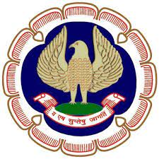
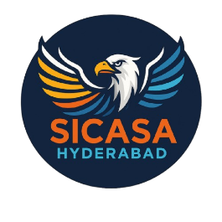
NEWSLETTER- FEBRUARY 2026
SAARATHI
~THE VOICE THAT LEADS~

Hyderabad BRANCH OF SIRC OF ICAI
&
HYDERABAD BRANCH OF SICASA
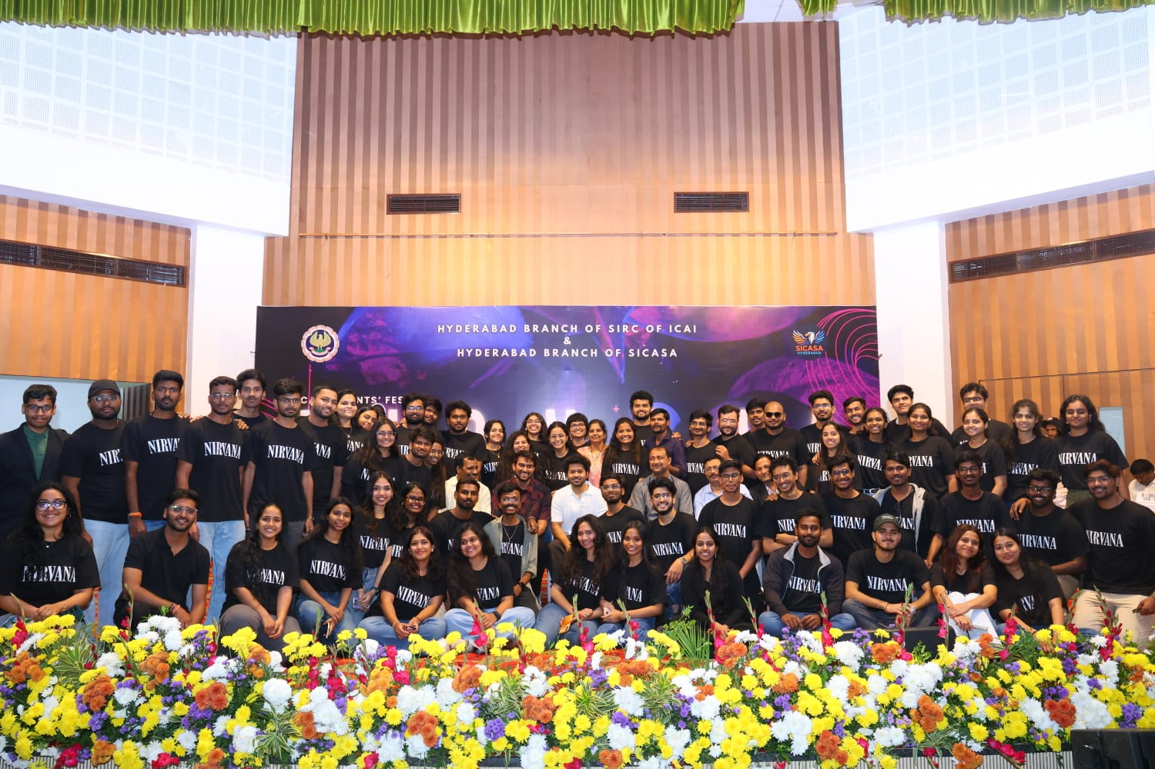

Snapshots from Nirvana Fest on 08thFebruary 2026, at RTC Kalabhavanwhere approximately 1200+ students came together to enjoy fest.

CONTENTS

S. NO. | PARTICULARS | PAGE NO.
1 | OFFICE BEARERS OF SICASA HYDERABAD 2025 - 26 | 2
2 | MESSAGE FROM STUDENT COMMITEE | 3
3 | FEBRUARY MONTH PHOTO GALLERY | 14
4 | INVITATION FOR ARTICLE | 21

Disclaimer:
The Hyderabad Branch of SIRC or SICASA Hyderabad does not accept any responsibility for the views expressed by different contributors. The views and opinions expressed.in the articles are of the author and SICASA Hyderabad is not necessary to agree with the views.

OFFICE BEARERS OF SICASA HYDERABAD 2025-26
C. GOUTHAM SIDDHARTH
SSF CO-ORDINATOR
T. LOKESHWARAO
JOINT SECRETARY ACADAMICS
B. SATYA SAMPAT KUMAR
TREASURER
TALHA YASAR
JOINT SECRETARY EVENTS

PIYUSH KABRA
JOINT TREASURER

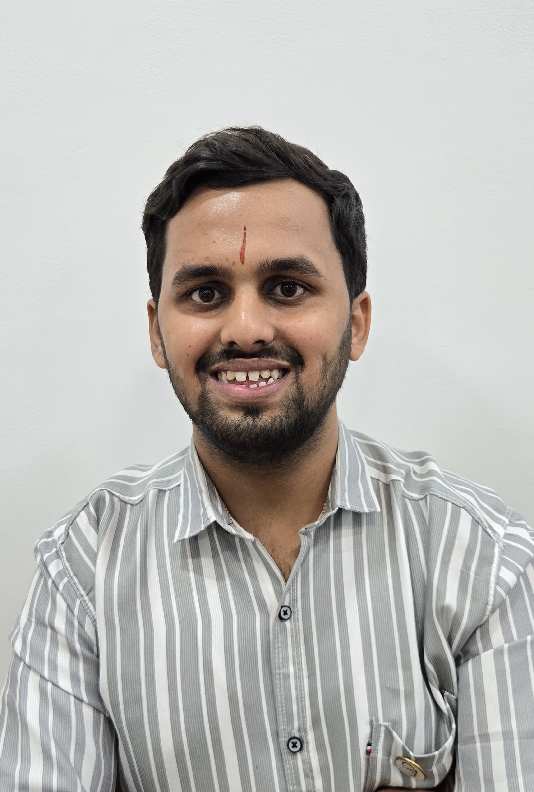
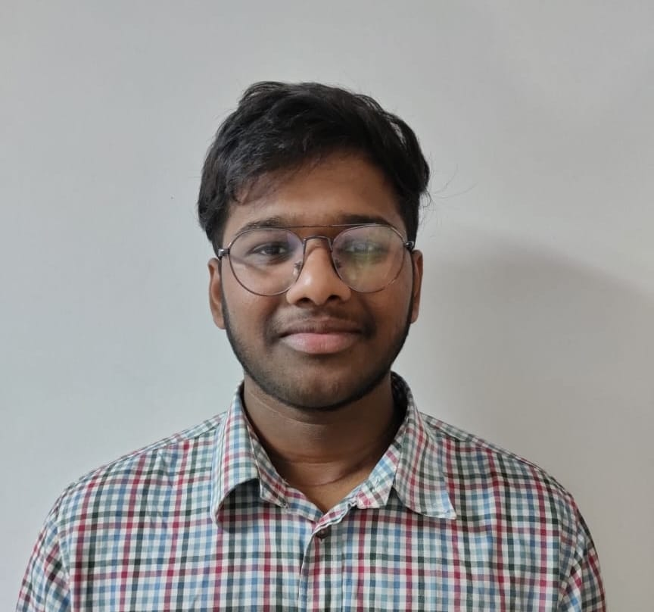
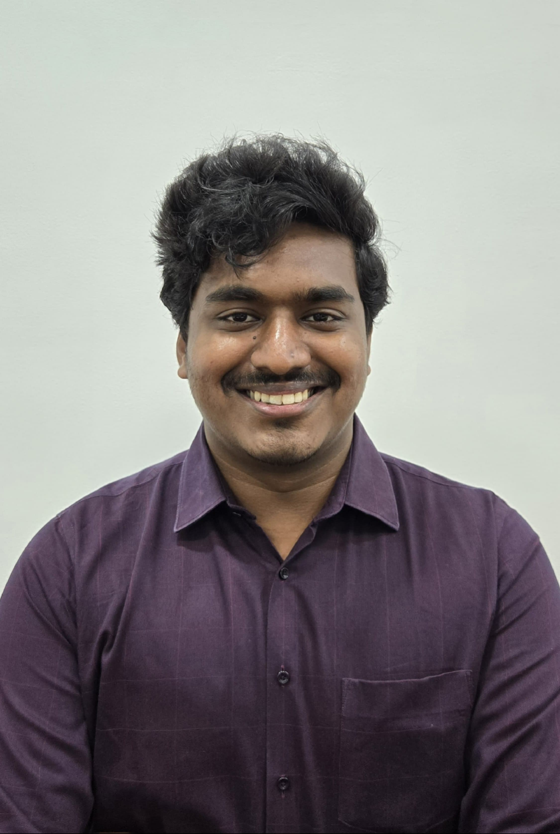
SUMANTH VEMURI
VICE-CHAIRMAN
V.V MADHUSREE
SECRETARY
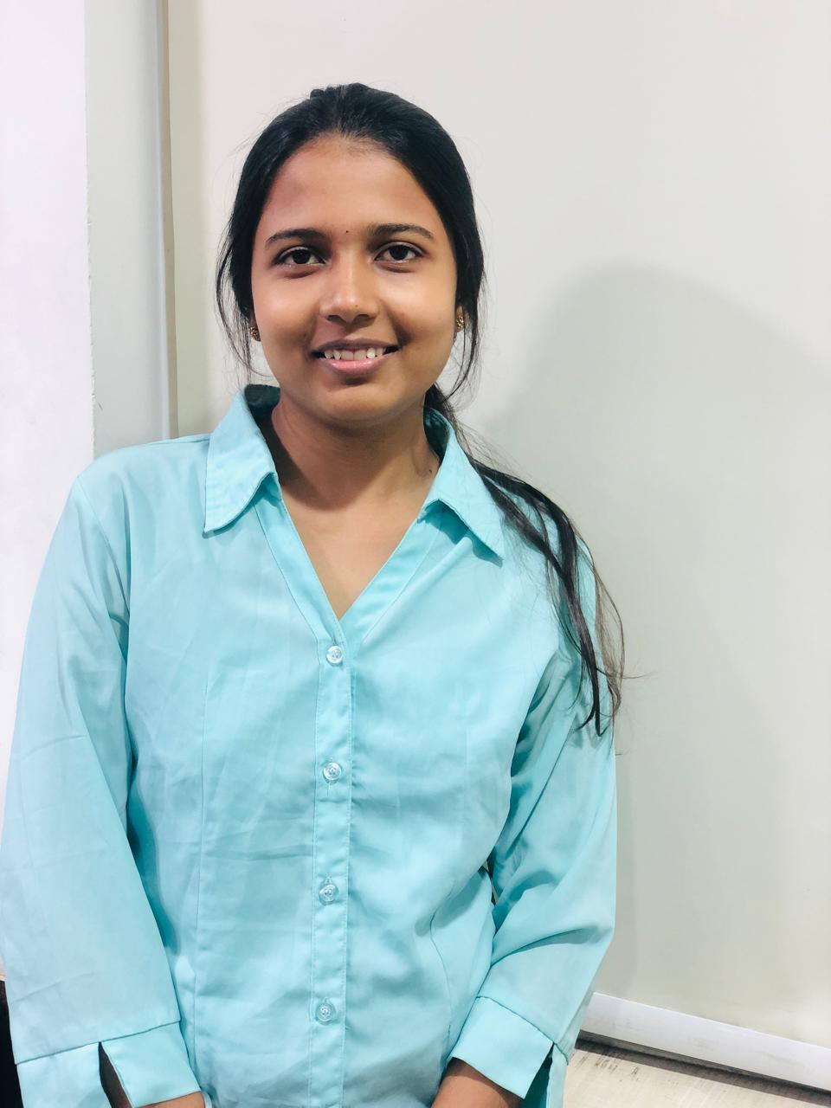
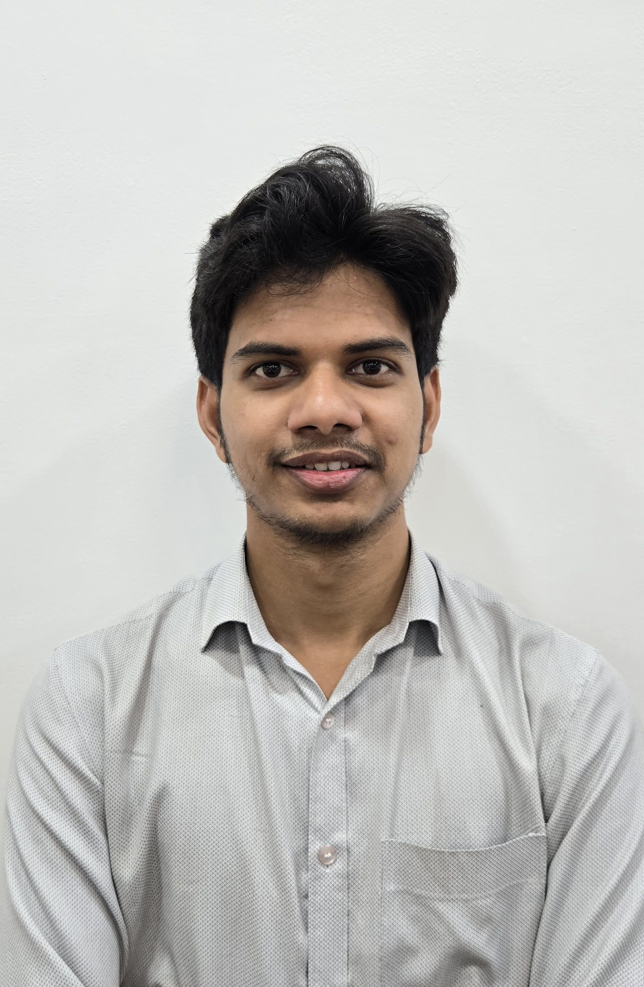
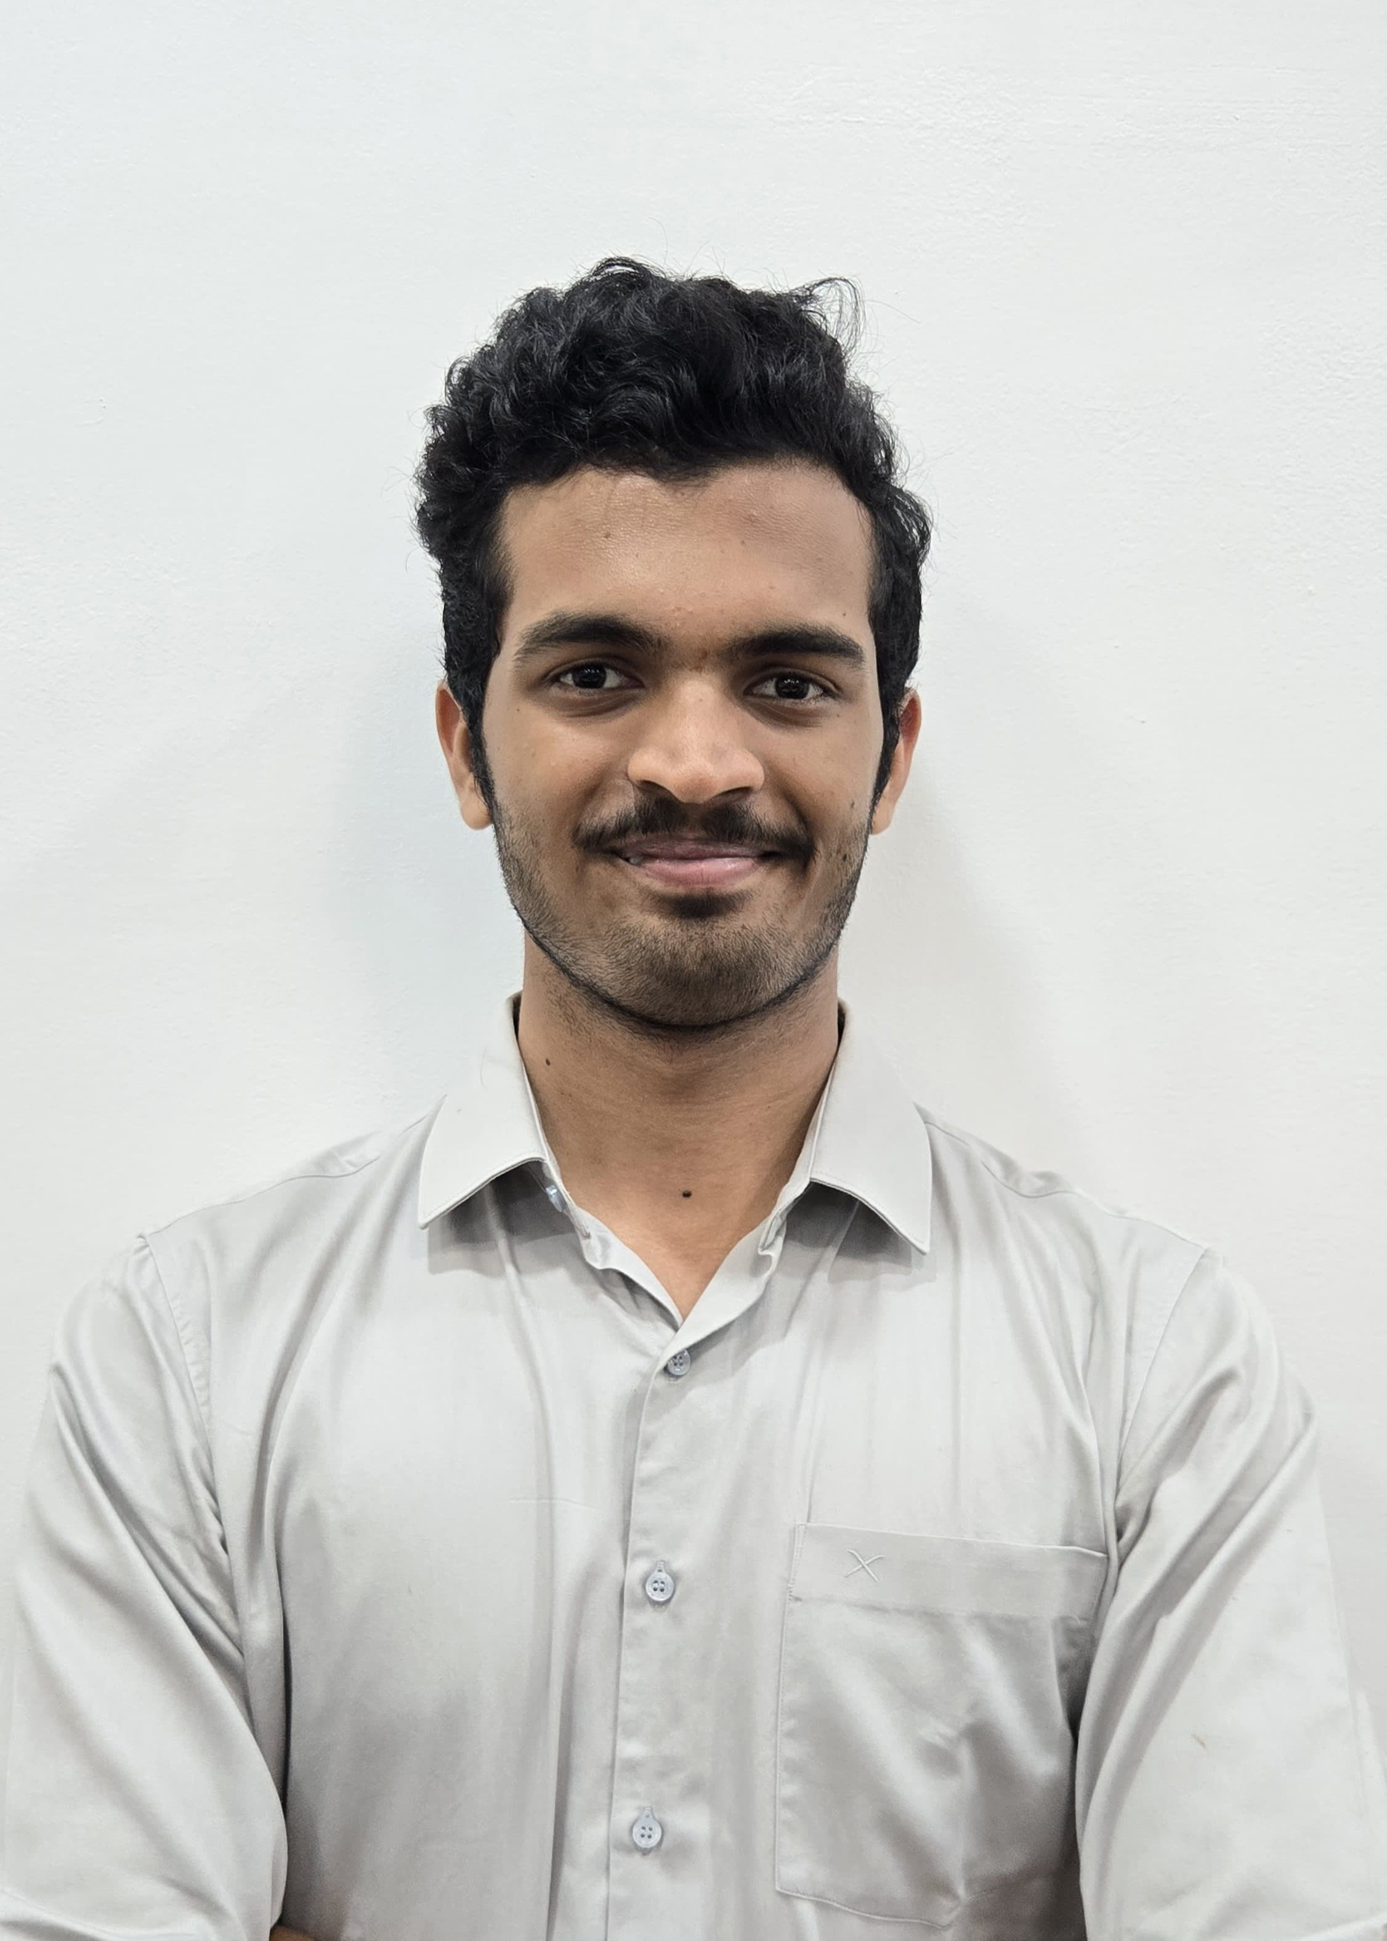
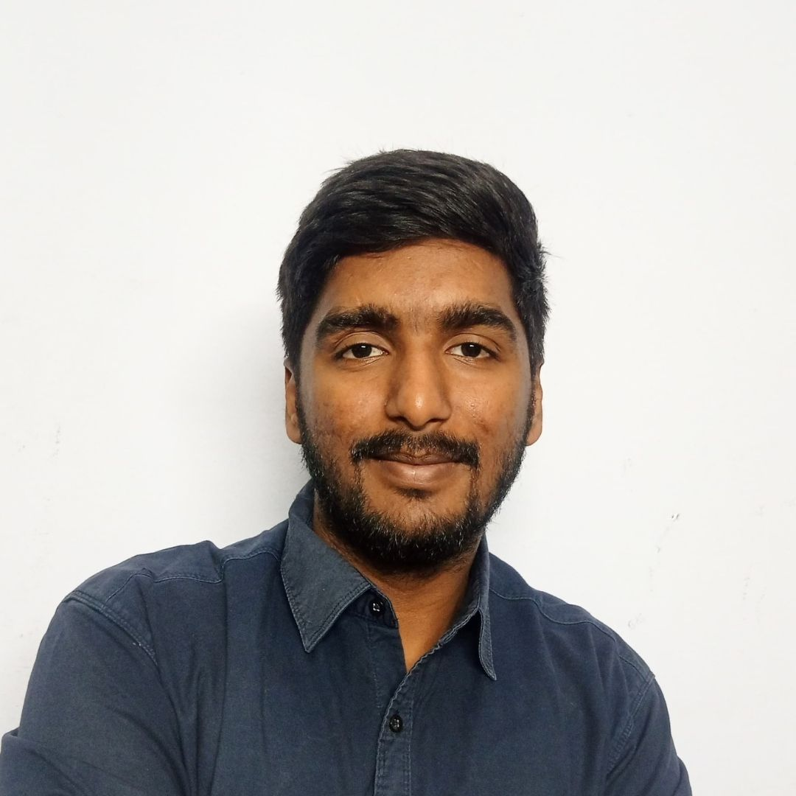
K. NAGA SRITHA
CULTURAL CURATOR
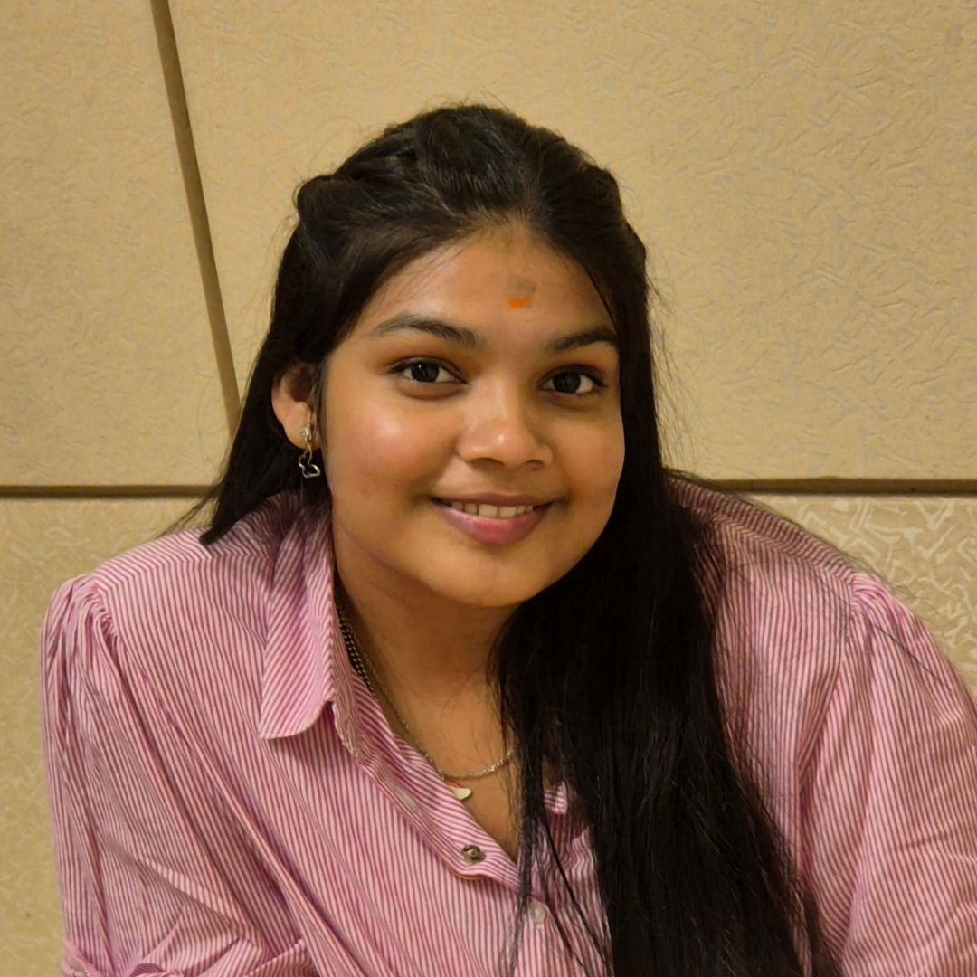
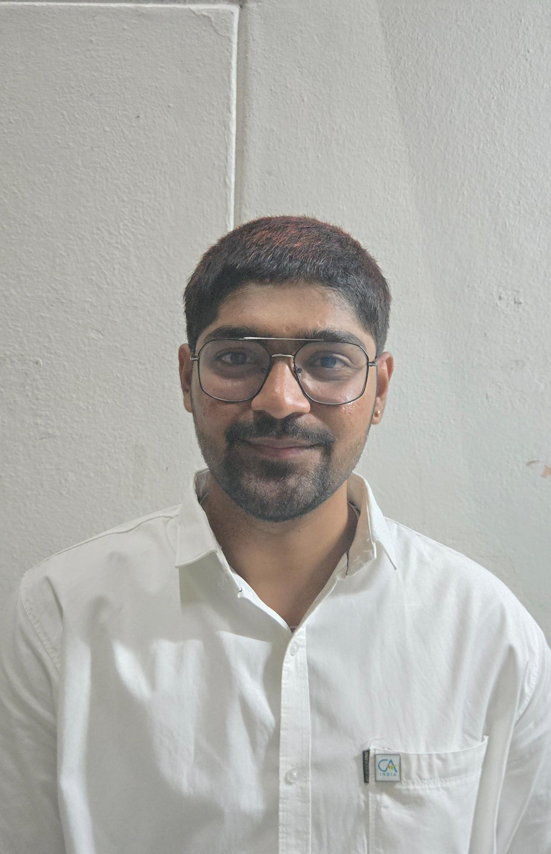
E. NITISH
SPORTS CO-ORDINATOR
K. AASHA SAILU SREE
CREATIVE HEAD
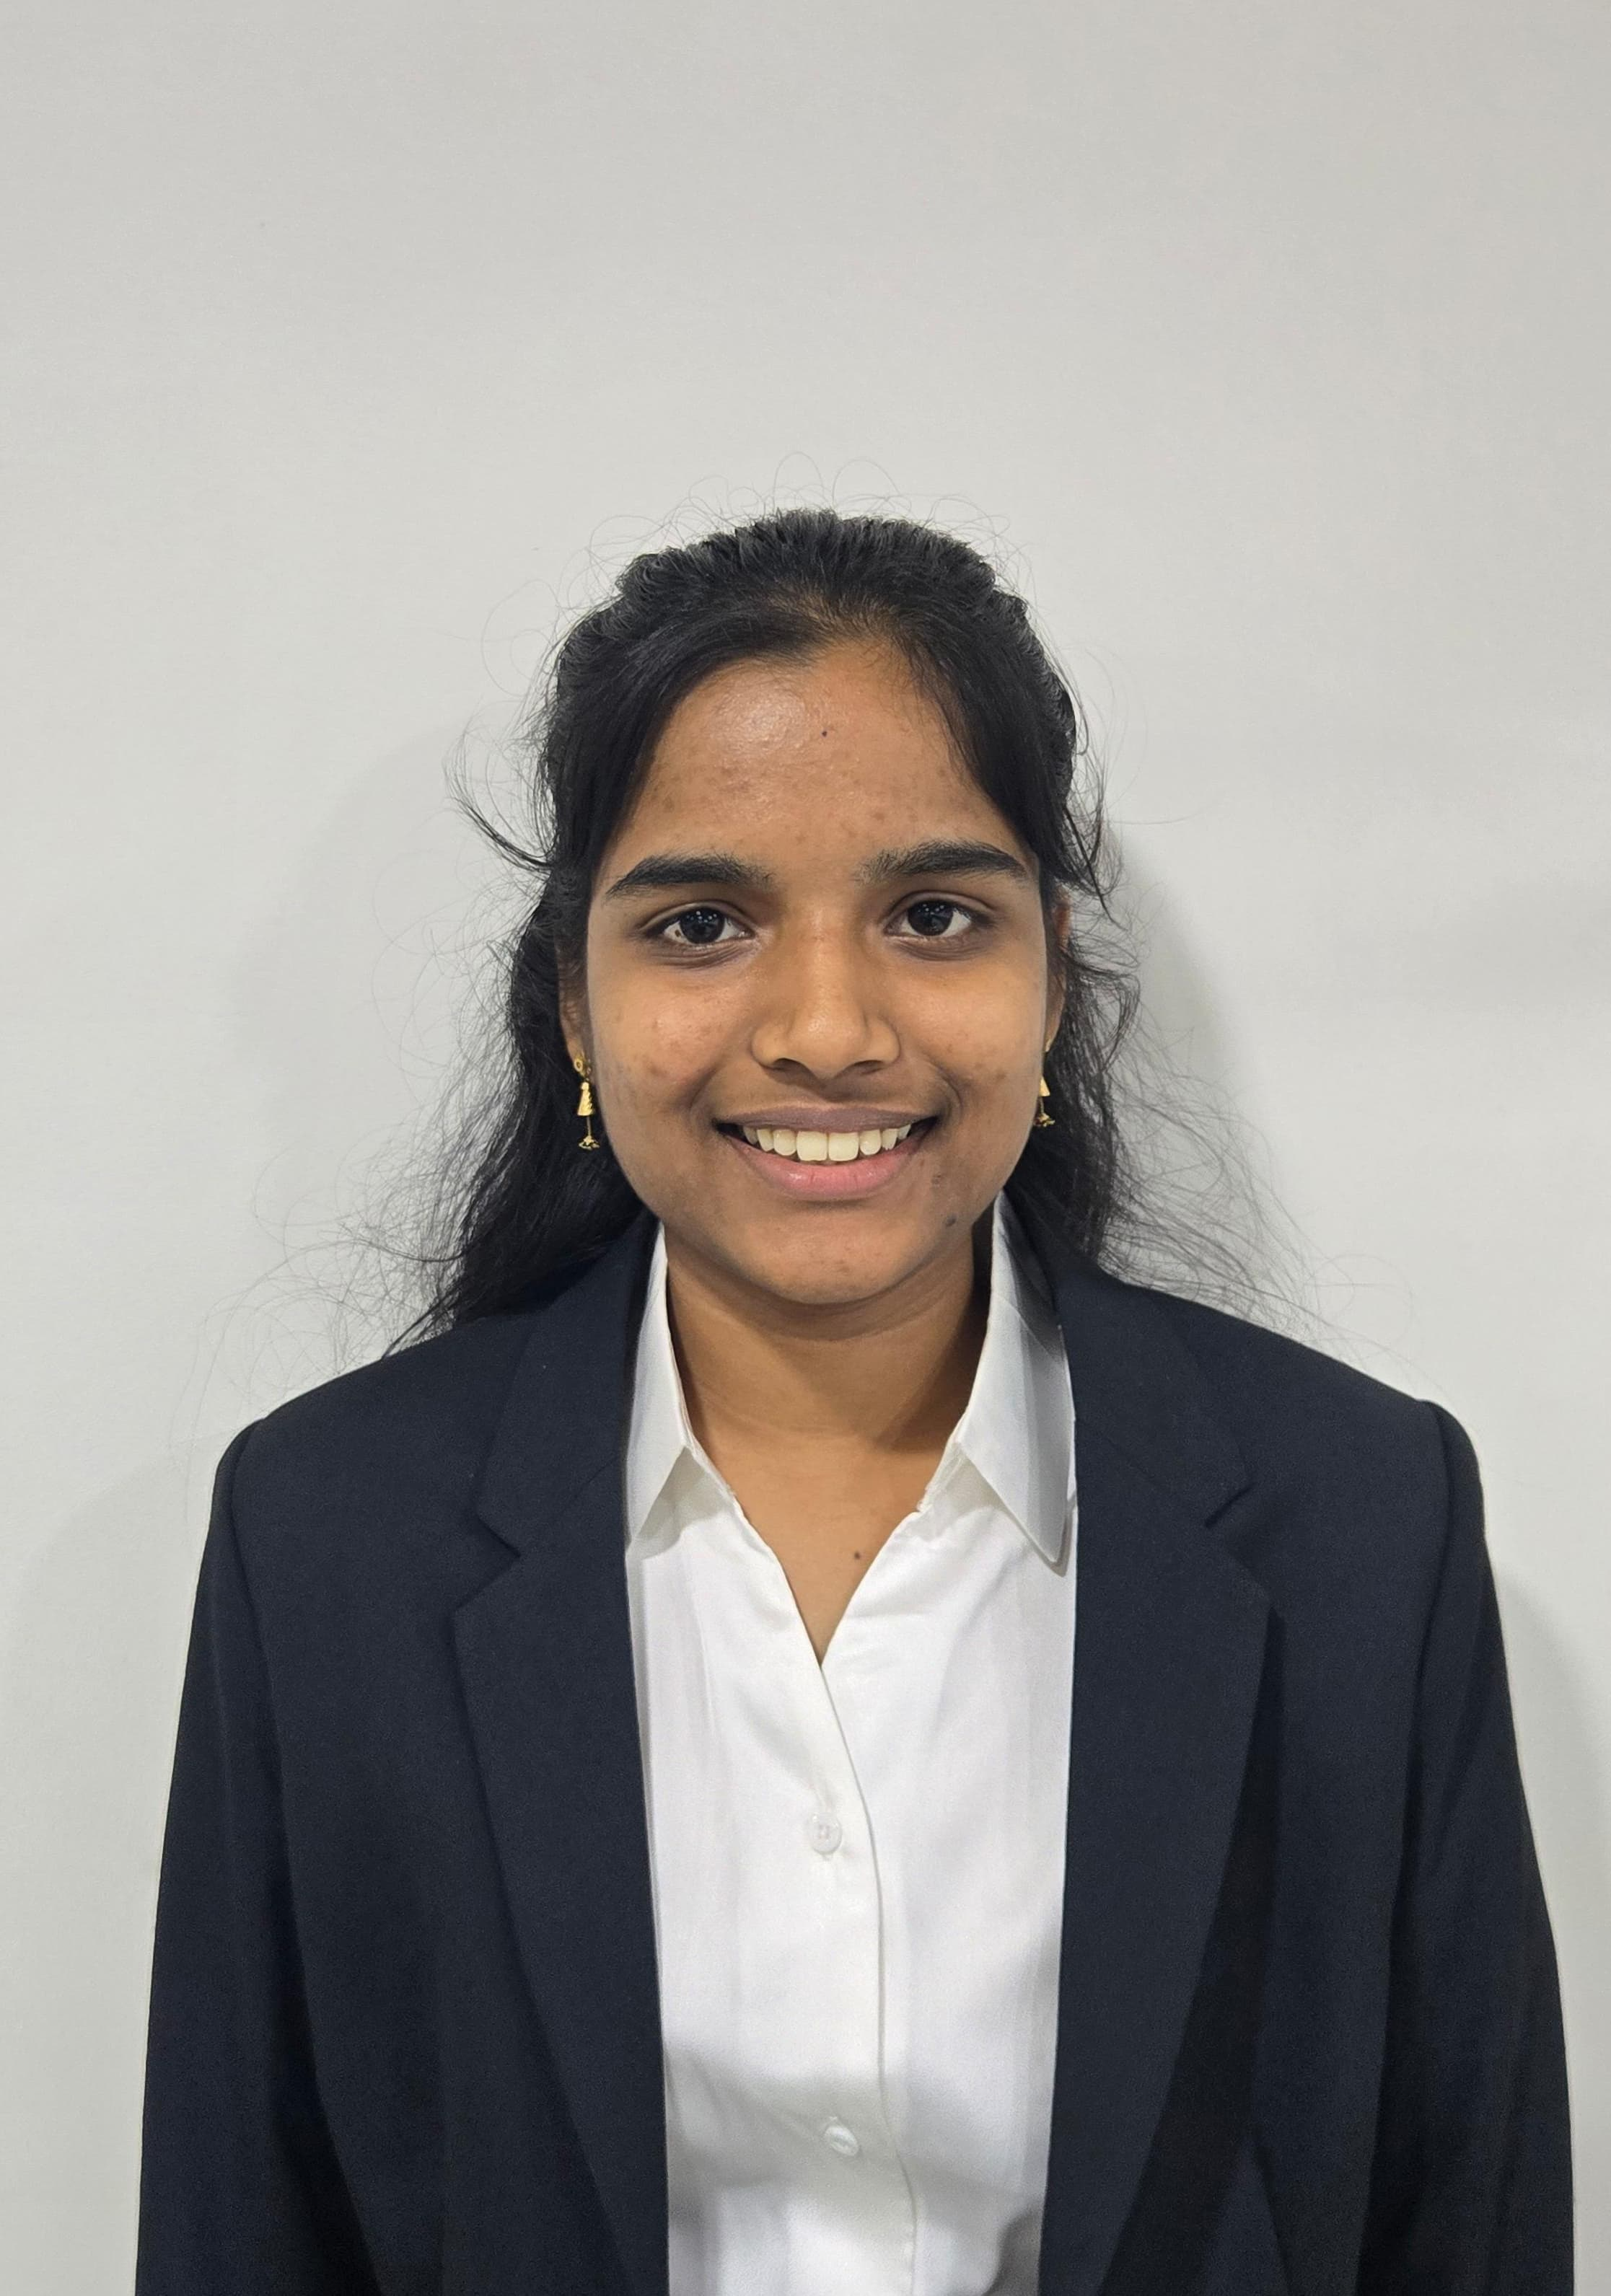
CA. Mukkara Sai Charan Reddy
SICASA CHAIRMAN

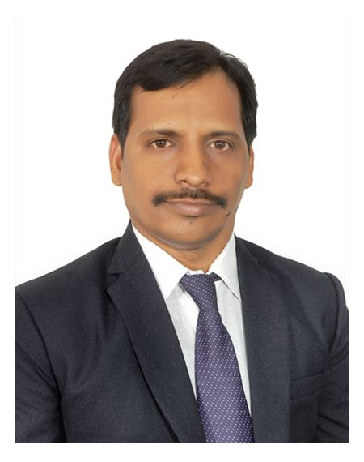
CA. Gonugunta Murali
SICASA CO-CHAIRMAN

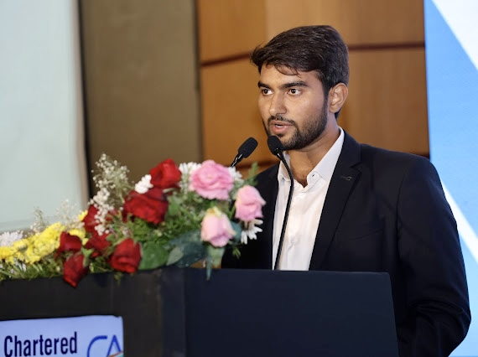
STUDENT COMMITTEE MEMBERS 2025-26
SICASA HYDERABADCHAIRMAN'SMESSAGE
Serving as the Chairman of SICASA Hyderabad has been an incredibly rewarding journey, one that continues to shape my perspective on leadership, teamwork, and the strength of the CA student community.
As I reflect on the year gone by, I am reminded that it was never just about organising events or achieving milestones. It was about creating opportunities for students to learn, connect, and grow together as a community.
Our journey began with the Bank Audit Seminar, where the participation of more than 400 students set an encouraging tone for the year ahead. The enthusiasm and engagement we witnessed that day reaffirmed the commitment of our student community towards continuous learning.
The Logo Launch soon followed, marking the beginning of our committee’s identity for the year. It symbolised not just a new chapter, but the shared vision and collective efforts of a team determined to make a meaningful difference.
One of the proudest moments of our tenure was Pravaha, our flagship conference that brought together nearly 2,500 students. The scale of the event and the vibrant exchange of ideas over those two days truly reflected the spirit of collaboration and intellectual curiosity among CA students.
Another memorable milestone was Nirvana, the cultural fest of CA students, where nearly 1,200 participants came together to celebrate creativity, talent, and camaraderie. It was inspiring to witness the passion and energy that filled the stage and the audience alike.
None of these achievements would have been possible without the relentless efforts of our committee members, the dedication of our volunteers, and the constant encouragement from the student community. Their support has been the driving force behind every initiative we undertook.
While the year gave us many proud moments, it also came with its share of challenges. Each challenge, however, strengthened our resolve and reminded us that meaningful outcomes are always the result of collective perseverance.
As we step forward into the next phase of this journey, I remain deeply grateful for the trust and support extended to our team and me. The experiences of the past year only strengthen our commitment to continue creating impactful opportunities for the student community.
The journey continues, and I look forward to building on this momentum together.

With gratitude,

CA. Mukkara Sai Charan Reddy
Chairman,
SICASA Hyderabad
SICASA HYDERABAD CO-CHAIRMAN'S MESSAGE

Being a part of SICASA Hyderabad as the Co Chairman has been a truly enriching experience. The past year has been filled with opportunities to learn, collaborate, and strengthen the bond within the CA student community.
From the Bank Audit Seminar that saw the participation of over 400 students, to Pravaha, where nearly 2,500 students came together for learning and exchange of ideas, every initiative reflected the enthusiasm and spirit of our community. Nirvana, our cultural fest with close to 1,200 students, further celebrated the creativity and vibrant energy of CA students.
These moments were made possible by the dedicated efforts of our committee members, volunteers, and the constant support of the student community.
Grateful to be a part of this journey and looking forward to continuing many more meaningful initiatives together.

With gratitude,
CA.Gonugunta Murali
Co-Chairman,
SICASA Hyderabad

SICASA HYDERABADVICE CHAIRMAN'S MESSAGE
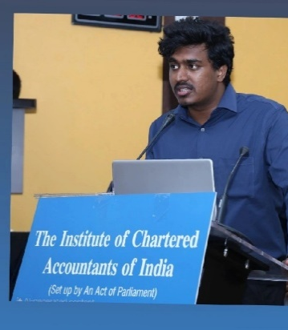
Dear Fellow Students,
As our term at SICASA Hyderabad comes to an end, I want to take a moment to reflect with a lot of gratitude and emotion. Serving as the Vice Chairman of SICASA Hyderabad has truly been a memorable journey for me.
This role was never just about holding a title. For me, it was always about responsibility, learning, and doing whatever I could to contribute to a community that means so much to all of us as CA students.
Throughout this term, we tried our best to create a platform where students could learn, participate, and grow together. Some things happened exactly the way we planned, while some things didn’t go the way we hoped — and that’s completely part of any journey. But one thing always remained constant: our intention to keep improving and moving forward.
My only aim during this term was simple — to take SICASA to greater heights. I sincerely hope that, in some way, I was able to contribute towards that goal. Even if we improved by just 1% compared to the previous year, I would consider that a step in the right direction. The idea was never to compare or reduce the efforts of the past committees, but to build on their work and keep the momentum going.
I would also like to take a moment to thank our amazing volunteers. Your unwavering support, time, and effort behind the scenes made every event possible. Many of the things we were able to do this year happened because of your dedication, and I’m truly grateful for that.
SICASA has always been bigger than any one person. It is built on the collective energy of students who step forward, contribute, and support one another.
As this term comes to an end, I want to wish the upcoming committee the very best. I am sure they will bring new ideas, fresh energy, and take SICASA Hyderabad to even greater heights.
And finally, to every student who attended our events, supported our initiatives, or even shared a simple word of encouragement thank you. Your participation is what truly gives life to SICASA.
Before I conclude, I just want to say this — positions may change and terms may end, but the experiences, friendships, and memories we create here stay with us forever.
SICASA has given me more than just an opportunity to serve; it has given me lessons, relationships, and moments that I will always carry with me.
I truly believe that the strength of SICASA lies in its students — in the ideas we share, the support we give each other, and the belief that together we can always do better.
As I step away from this role, I do so with gratitude in my heart and hope for the future.
Thank you for trusting me, supporting me, and being part of this journey.
Warm regards,
Sumanth Vemuri
Vice Chairman,
SICASA Hyderabad
SICASA HYDERABAD SECRETARY’S MESSAGE
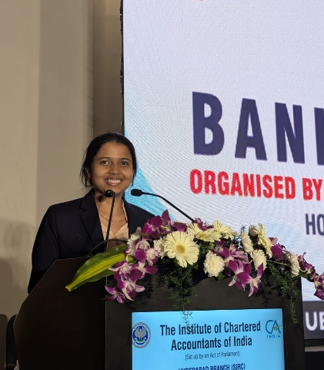
One of the most beautiful phases of my life has been my journey with SICASA Hyderabad. From being a Student Delegate to volunteering and eventually serving as the Secretary, the journey unfolded with growth, responsibility, and countless lessons. Each stage brought new experiences that shaped my perspective and strengthened my connection with the student community.
Our tenure began on a strong note with the Bank Audit Seminar, where a packed hall of over 400 students set the tone for the year ahead. It was more than just the first event of our series; it reflected the enthusiasm, trust, and engagement of the student community.
Soon after, the Logo Launch Event marked the unveiling of our collective vision and aspirations for the year. It symbolised the beginning of a journey that would be defined by learning, collaboration, and meaningful student engagement.
One of the most defining highlights of our journey was Pravaha, our conference that brought together nearly 2,500 students and an ocean of ideas. Those two days were a celebration of learning, collaboration, and inspiration. Being closely involved in the Master of Ceremonies (MOC) responsibilities throughout the year became a deeply special part of my experience. One of the proudest moments was sharing the stage with the Honourable Deputy Chief Minister Bhatti VikramarkaGaru, a rare and unforgettable moment. Hosting our Guest of Honour, Akkineni Naga Chaitanya Garu, was something I had never imagined adding to my bucket list.
The celebration of talent and creativity continued with Nirvana, the cultural fest of CA students, where nearly 1,200 students came together to showcase the vibrant spirit of our community. Watching the stage come alive with performances, witnessing the excitement among the audience, and feeling the electrifying energy throughout the venue was an experience beyond words.
Hosting events gradually became one of the most fulfilling aspects of my journey. The stage, in many ways, became a space where I truly belonged. welcoming speakers, connecting with the audience, and experiencing the energy of every moment as it unfolded. These are memories I will forever cherish, even after the curtains fall. Hosting Mr. MouliTanuj Prashanth was yet another unexpected yet delightful highlight of this journey.
Like every meaningful journey, this year also came with its share of challenges. There were moments of pressure and uncertainty, but each time, it was the unwavering support of our team, volunteers, and the student community that made the journey worthwhile.
Serving as the Secretary of SICASA Hyderabad has been far more than holding a position. It has been a journey of responsibility, learning, friendships, and memories that I will always cherish.
As I sign off from this role, I extend my heartfelt gratitude to every person who has been a part of this incredible journey. I gave it my all and carry no regrets. I sign off from one of the most beautiful chapters that taught me patience, confidence, and leadership. Awaiting new beginnings, with so much more to conquer.
With a lot of gratitude and pride,

VV. Madhusree
Secretary,
SICASA Hyderabad.
Signing off.
SICASA HYDERABAD TREASURER’S MESSAGE
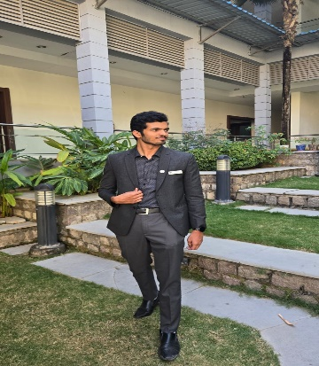
Serving as the Treasurer of SICASA Hyderabad has been one of the most enriching and memorable chapters of my student journey. What began as an opportunity to contribute to the CA student community gradually transformed into a deeply fulfilling experience filled with learning, teamwork, challenges, and countless meaningful moments.
From attending events as a participant, helping conduct events as a volunteer to finally organising an event as a committee member of SICASA. This journey was filled with memories and learnings for life. Being entrusted with the responsibility of managing the budgets of this vibrant community was both an honour and a learning experience. The role required not only diligence and accountability but also a constant effort to ensure that every initiative we undertook was executed responsibly and efficiently. No matter how many versions of the budget was created, we had only one version of the event to make an impact.
During my tenure, I had the privilege of being part of several events and initiatives that brought together students from across Hyderabad. From academic sessions and knowledge-sharing platforms to cultural events, sports tournaments, and student engagement activities, every event reflected the collective energy and enthusiasm of our student community. Behind every successful event was a team of passionate individuals whom we call them volunteers who worked tirelessly, often behind the scenes, to make things happen.
One of the biggest takeaways from this journey has been the power of teamwork. Working closely with my fellow managing committee members, volunteers, and mentors taught me that impactful outcomes are always the result of collective effort. The camaraderie, late-night planning discussions, problem-solving moments, and shared excitement after successful events are memories I will always cherish. I would still always remember this one line said by a participant “The stage is big and the standards are set high” showing exactly our committee's vision and commitment towards improving this student's association from where it was to where it is. Managing the social media and looking at the growth we achieved this year is something that we take pride in. Being the 3rd highest followed CASA page in the country and the highest in Southern India CASA (11.5k followers) I'm proud with how it went.
This role also helped me grow personally. It strengthened my sense of responsibility, improved my organizational and coordination skills, managing my time between due dates of articleship and the dates of events and gave me the confidence to take initiative and lead.
SICASA will always remain a special part of my CA journey. I hope the initiatives and memories created during our tenure continue to inspire and benefit many more students in the years ahead.
Wishing the upcoming team the very best as they continue to take SICASA Hyderabad to greater heights.
B Satya Sampat Kumar
Treasurer,
SICASA Hyderabad

SICASA HYDERABAD JOINT SECRETARY- EVENTS MESSAGE

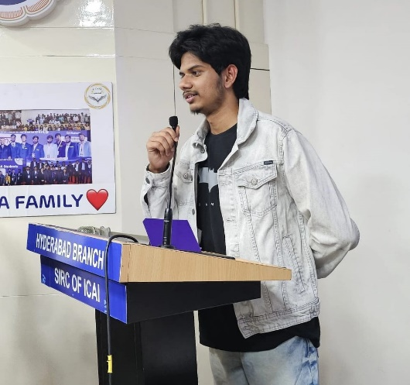
One of the most beautiful phases of my life has been my journey with SICASA Hyderabad. From being a Student Delegate, to volunteering, and eventually serving as the Joint Secretary – Events, this journey has been filled with learning, responsibility, and countless memorable moments.
Our tenure began with the Bank Audit Seminar, where a packed hall of more than 400 students set the tone for the year ahead. Soon after, the Logo Launch Event marked the beginning of our vision for the year. One of the most defining highlights was Pravaha, our flagship conference that brought together nearly 2,500 students for two days of learning, collaboration, and inspiration. Being involved in the Master of Ceremonies (MOC) responsibilities throughout the year was a truly special experience. Sharing the stage with the Honourable Deputy Chief Minister Shri Bhatti VikramarkaGaru and hosting our Guest of Honour Shri Akkineni Naga Chaitanya Garu were unforgettable moments.
The celebrations continued with Nirvana, the cultural fest of CA students, where nearly 1,200 students showcased the vibrant spirit of our community. Over time, hosting and coordinating events became one of the most fulfilling aspects of my journey. The stage became a space where I truly belonged—welcoming speakers, connecting with the audience, and experiencing the energy of every moment.
Behind every successful event was a dedicated team of committee members and volunteers who worked tirelessly. This journey reinforced the true power of teamwork, collaboration, and shared vision. Seeing the growth of our social media presence, now standing as the 3rd highest followed CASA page in the country and the highest in Southern India with over 11.5k followers, is something we take immense pride in.
Serving as the Joint Secretary – Events of SICASA Hyderabad has been far more than holding a position. It has been a journey of leadership, friendships, and memories that I will always cherish.
As I sign off, I extend my heartfelt gratitude to the Hyderabad Branch of ICAI, the SICASA Chairman and committee members, our volunteers, and every CA student who supported our initiatives.
I close this chapter with immense gratitude and pride, carrying forward the lessons, memories, and friendships this journey has given me.
Until we meet again on the other side of the journey.
Talha Yasar
Joint Secretary- Events,
SICASA Hyderabad

SICASA HYDERABAD JOINT TREASURER HEAD MESSAGE
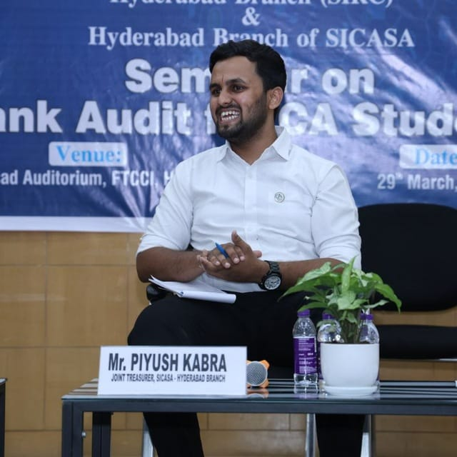
Some chapters of life always stay very close to your heart — and being a part of the *SICASA Hyderabad Student Managing Committee* is definitely one of those for me.
I still remember the days when I used to volunteer at SICASA events and quietly dream that someday I would also become a committee member. Back then, there was always a little self-doubt within me — Would I be able to manage everything? Would I be capable enough?
But looking back today, I can confidently say that becoming a part of this committee was one of the best decisions I made.
This journey has helped me grow not only *professionally but also personally*. It gave me the opportunity to build meaningful connections, meet amazing people, and expand my network in ways I never imagined.
From organizing the *National Conference, **Cultural Fest, **Sports Meet, **seminars, and **marathons* — every event came with its own set of learnings, challenges, and unforgettable memories.
These experiences taught me leadership, teamwork, coordination, and most importantly the joy of working together for something bigger than ourselves.
I would like to express my heartfelt gratitude to the *Managing Committee of the Hyderabad Branch, and all my **co-committee members* who were always supportive and made this journey incredibly enjoyable.
A special thanks to our amazing *SICASA Hyderabad volunteer team*, who worked tirelessly behind the scenes and ensured that every event turned out fantastic.
Thank you to each and every one of you for making this experience so memorable. These memories will always stay with me.

Until next time…

Signing Off,
Piyush Kabra
Joint Treasurer,
SICASA Hyderabad

SICASA HYDERABAD CREATIVE HEAD MESSAGE
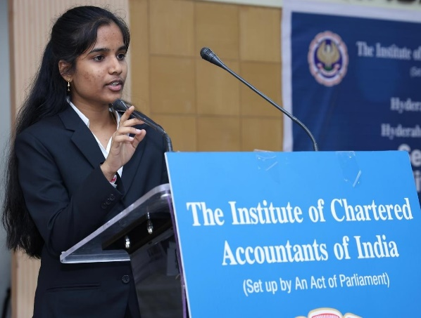
It’s really surprising that it has almost been a year since the 2025-26 Students’ Managing Committee was formed, and we have completed a whole year of our tenure. It is truly a bittersweet moment as we reach the end of our term. Starting from the Student’s Bank Audit Seminar in March 2025, which was our first event, to the recent Women’s Day celebrations we conducted on 8th March 2026, I can’t believe a full year has passed. Every event has been memorable, and there was something to learn from each one. Our term also included two major, fabulous, and mind-blowing events: "PRAVAHA – The Flow of Future," the 2-day National Conference of CA Students at Hyderabad, which was a huge success with over 2,000 students from various states of India in June 2025—a perfect blend of academic sessions and fun activities. This was followed by another major event, the CA Students Fest, NIRVANA - "Beyond the Ordinary," held in February 2026, where almost 1,000 students attended. It was an absolute blast, with students forgetting about books for one complete day and enjoying to their hearts' content with various song performances, dance performances, skits, games, and jamming sessions. Many other events were conducted during our term, such as the Logo Launch, Sports Tournaments, Industrial Visit, National Talent Search Competitions, and Marathons, to which we contributed in some way or another. For most of the events, we received multiple positive feedbacks, which was the sole motivation for our continued efforts in organising them. Thanks to our Chairman, Sai Charan Sir, and Co-Chairman, G Murali Sir, for providing me this opportunity and always supporting us and our ideas during the tenure. Next, a huge shoutout to our volunteers, who have always been the backbone of our events and helped us organise and manage everything smoothly. We have created good bonds and have become good friends throughout the tenure. I genuinely appreciate every SICASA volunteer for your impactful efforts during the events. Last and most importantly, to my 9 co-committee members: at the beginning of my term, I did not know any of the committee members as I was fairly new to SICASA, but starting from our introductions on election day, to our first official meeting on the same day, to all the events we have collectively conducted—where we took up different roles and stood by each other’s side supportively, and to the late-night Google Meet planning sessions—each and every instance brought us all even closer. We have all become very good friends, which is actually an understatement because now we interact with each other not just for SICASA activities but also for various aspects of our lives. I am really grateful for the amazing and fun team that I have had throughout my tenure, with whom I could share anything and seek advice. Each and every member is very supportive, helpful, jovial, and understanding. I have learned a lot during my tenure that I will always carry with me. To conclude, completing my term as Creative Head has been a whirlwind experience filled with creativity, challenges, and unforgettable memories.
With gratitude,
KandikondaAashaSailuSree
Creative Head,
SICASA HYDERABAD

SICASA HYDERABAD SPORTS CO-ORDINATOR MESSAGE
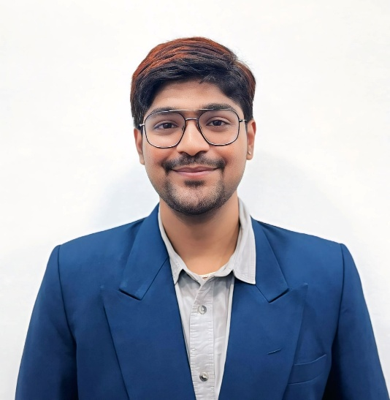
Serving as the Sports Coordinator of the Southern India Chartered Accountants Students Association (SICASA) - Hyderabad has been one of the most memorable and beautiful experiences of my journey as a student. Being a part of SICASA gave me an opportunity not only to contribute to the student community but also to grow as a person by taking responsibility, working with a team, and organizing events that brought everyone together through sports. I truly feel privileged and honored to have held this position and to have been associated with such a vibrant and supportive organization.
During my tenure, I had the opportunity to organize and conduct several sports activities for the students. Each event was filled with enthusiasm, participation, and team spirit, which made the efforts behind them completely worthwhile. One of the biggest highlights of my tenure was organizing the Open Ground Cricket Tournament. This tournament was particularly special because it was conducted after many years, and bringing it back successfully was a proud and satisfying moment for me. Seeing so many participants come together, enjoy the spirit of the game, and create unforgettable memories made all the hard work truly meaningful.
My journey in SICASA was filled with many beautiful moments. Of course, like any experience, there were both highs and lows along the way. There were challenges, pressures, and moments where things did not go exactly as planned. However, those challenges only helped me learn, improve, and become stronger. Looking back, I can confidently say that I enjoyed every single moment of this journey, and each experience has contributed to my personal growth.
I sincerely thank the Management Committee members for trusting me with the role of Sports Coordinator. Their guidance, encouragement, and support helped me grow, take initiative, and made my journey in SICASA truly meaningful.
I also thank my team for their dedication, support, and teamwork in making these events possible. I’m also grateful for the wonderful friendships and meaningful connections I built along the way, which made the experience truly memorable.
Finally, I would like to thank everyone who supported me throughout this journey—whether directly or indirectly. Your encouragement, trust, and cooperation meant a lot to me and helped make every event a success. Being a part of SICASA has truly been a wonderful chapter in my life, and I will always cherish the memories, experiences, friendships, and lessons that came along with it.
Nitish Varma
Sports Co-Ordinator,
SICASA Hyderabad
Signing Off.

SICASA HYDERABAD CULTURAL CURATOR’S MESSAGE

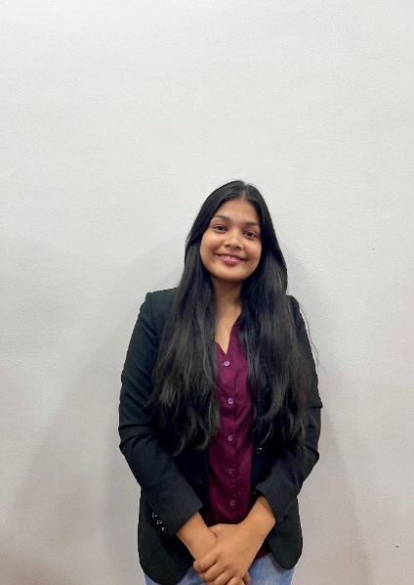
Serving as the Cultural Curator of SICASA Hyderabad during this term has been a truly memorable and enriching experience for me. It is hard to believe that this journey has already come to an end. Looking back, I feel grateful to have been part of a team that created so many meaningful moments and memories.
This tenure gave me the opportunity to meet many wonderful people, build new connections, and strengthen my professional network. More importantly, it was a learning journey. I have learned so much during this period — about teamwork, responsibility, and the practical aspects of organizing and managing events.
There were days filled with happiness and satisfaction, and there were also challenging days that tested patience and perseverance. But every experience, whether good or difficult, contributed to my growth and taught me valuable lessons.
Being able to contribute to the cultural activities of SICASA, especially heading the cultural segment during the conference, was one of the happiest moments.
Among all the events, the SICASA Fest holds a special place in my heart as I had the opportunity to oversee and manage it completely. Seeing it come together successfully was one of the most satisfying moments of this tenure.
I will always cherish the memories created during this journey and the friendships and connections formed along the way.
I sincerely thank everyone who supported, guided, and worked alongside me during this term. It has truly been an honor to serve as the Cultural Curator of SICASA Hyderabad.

Thank you.
Sritha
Cultural Curator,
SICASA Hyderabad

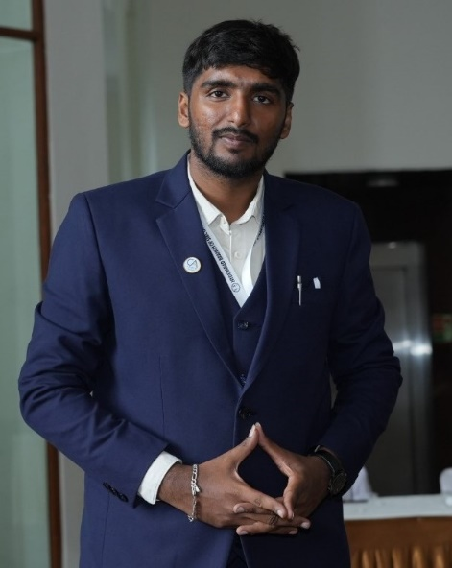
SICASA HYDERABAD STUDENT SPEAKER FORUM COORDINATOR MESSAGE
I Goutham Siddharth serving as the Student Speakers Forum Coordinator for SICASA Hyderabad has been one of the best and most memorable parts of my CA student life. Like a big beach under a clear night sky, it started with me just joining events—like dipping my feet in the water. Then I volunteered, riding the waves, and finally organized as a committee member. This turned into an amazing experience full of life lessons, strong teamwork, tough challenges, and happy memories that shine like stars.
This job in our lively CA student group felt like a big honor—like stars lighting the way. It was a great chance to learn, needing careful planning, fresh ideas, and full effort. Like building sandcastles as waves crash in, we worked through many late nights and plan changes, knowing each event was our one shot to make a real difference.
During my time, I helped run a bunch of events that brought students from all over Hyderabad together. Like stars lighting up the sky, they got brighter each time—from our first Bank Audit Seminar to the emotional farewell. We had Nirvana (the fun cultural fest), Pravaha (the national conference, where our team wore royal blue suits and looked super professional), Rang De Bharat (traditional day with everyone in colorful ethnic clothes), Sports Day (cricket, badminton, chess, carrom for guys and girls), and Women's Day. For that one, we split the team—like waves going different ways—some handled the celebrations, others the men's cricket. I even met SICASA teams from other branches, making our circle bigger.
The best part was our team—like bright stars guiding each other. I found people who really got me, turned my crazy ideas into real deals, and fixed fights or egos that never messed up our success. Each person was like a strong back support for the others. Those late nights planning, seeing I was missing from group photos (but smiling big when Google Photos randomly shows my favorite pics of me), and the joy after wins—these memories glow forever. Our social media work brought a huge jump in followers, especially during big events like the fest and conference. We hit 3rd highest-followed CASA page in the country (and #1 in South India at 11.5k)—something we're all proud of.
This whole ride changed me for the better, like beach waves smoothing rough stones. It built my skills in organizing, handling time between articleship work and events, taking responsibility, and leading with confidence. It showed me teamwork and good planning are like guiding stars for my future CA career.
As my time ends, I say a big thank you to the Hyderabad ICAI Branch, SICASA Chairman and committee, our hard-working volunteers, and every CA student who joined our events. SICASA Hyderabad will always be special in my CA story.
Thank you.
Gautham Siddharth
SSF Coordinator,
SICASA Hyderabad

PHOTO GALLERY
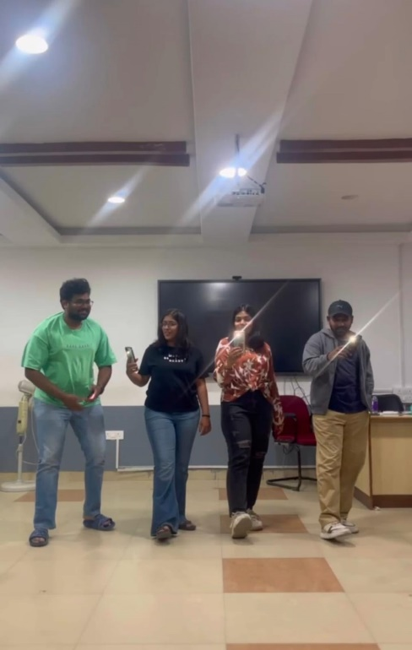
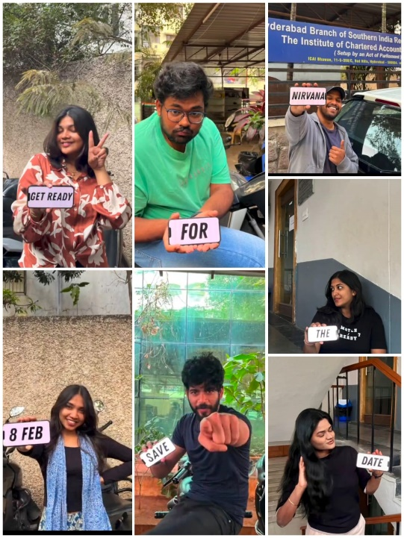
Snapshot from the reels day for the promotion of Nirvana-Beyond the ordinary held on 05rd&06th January 2026, at ICAI Bhavan, where volunteers and SICASA Committee has participated.

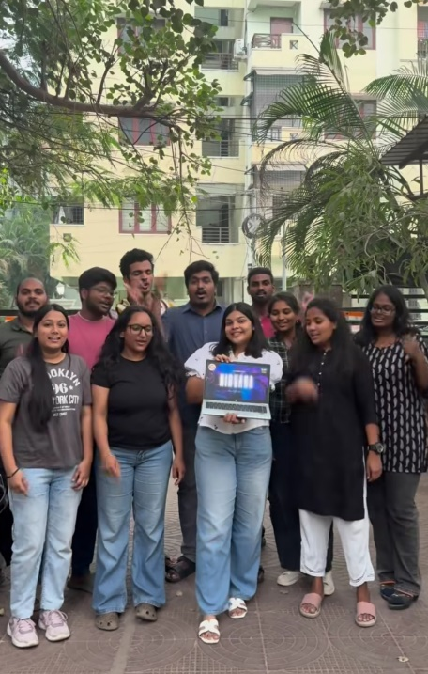
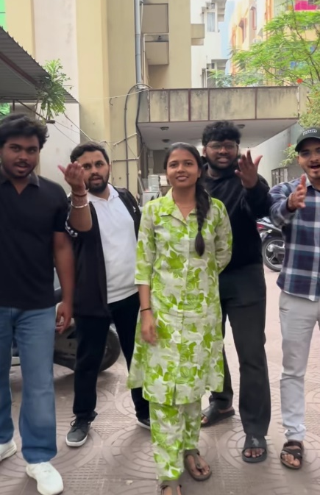

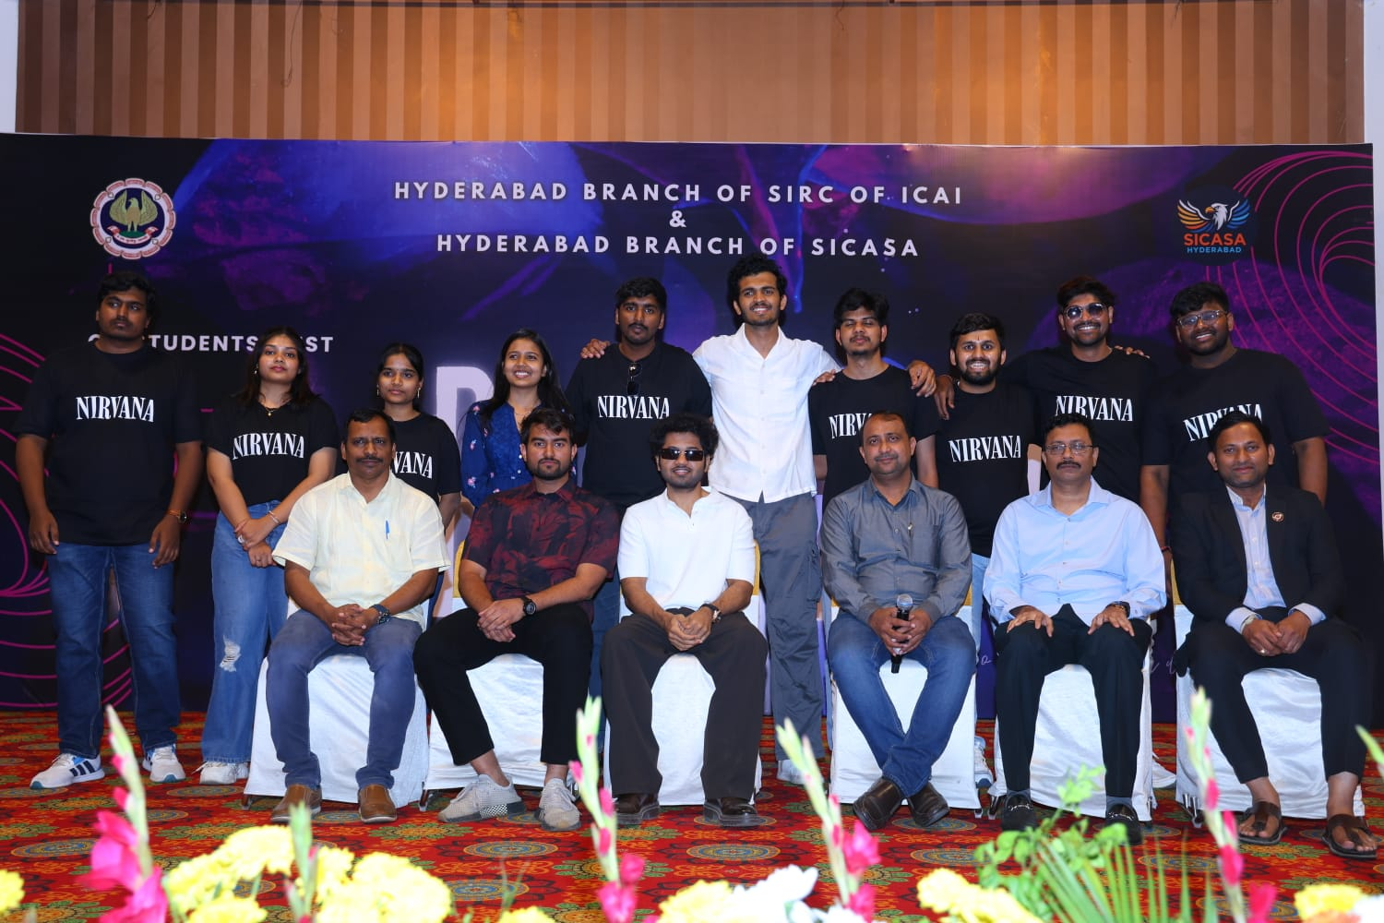

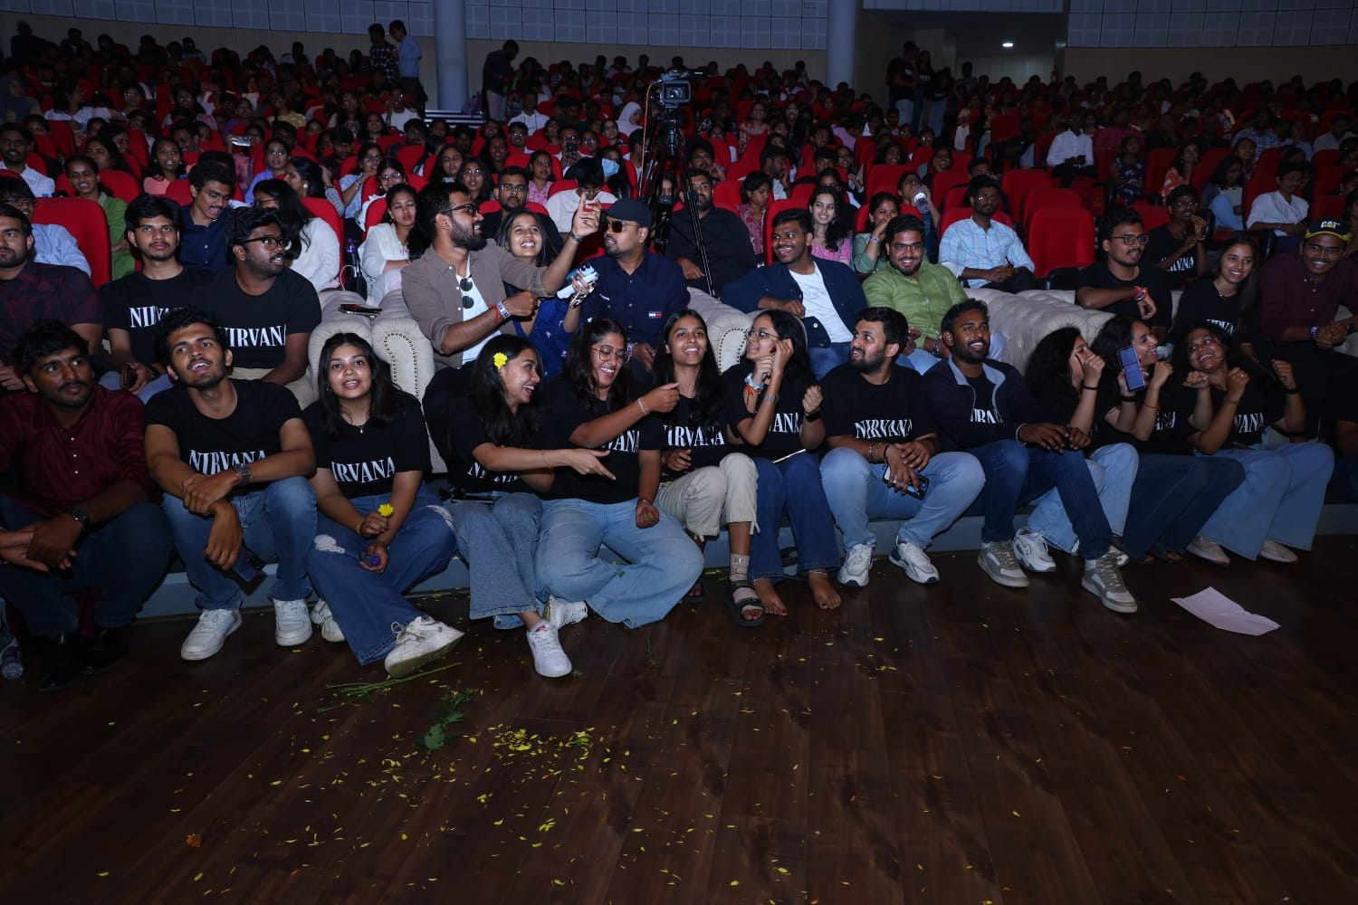

A snapshot from Nirvana – Beyond the Ordinary, held on 08th February 2026 at RTC Kalabhavan. The event was graced by Mr. MouliTanuj Prashanth as the Chief Guest, with the highlight of the day being an electrifying jamming session by Paatashala.

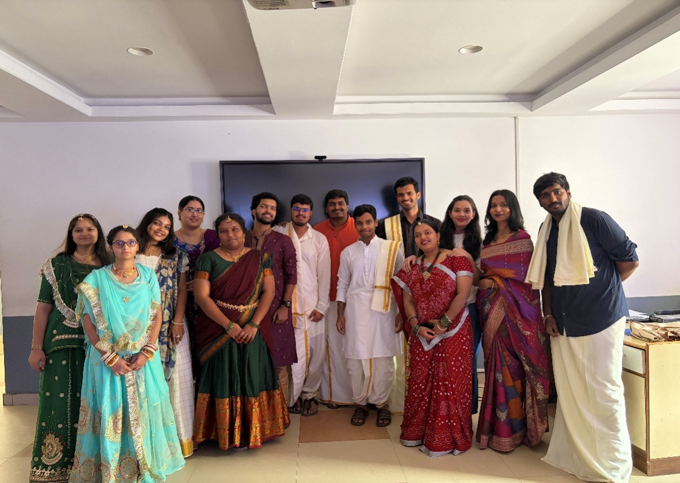

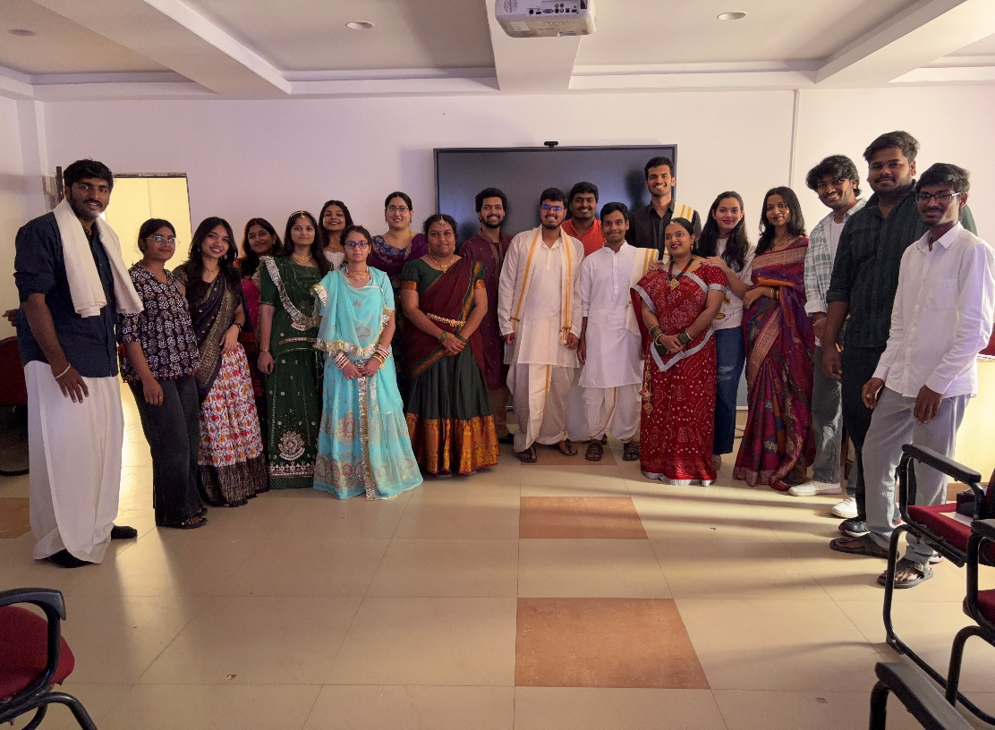

Snapshot from the celebration of Rang de Bharat held on 22nd February 2026, at Branch Premises.

INVITATION FOR ARTICLE

SICASA Hyderabad is inviting articles for the E-Newsletter: INSIGHT for the month of March 2026. All the students who want to get featured can submit their articles, artworks, poems, and short stories, etc., which are related to the Chartered Accountancy curriculum, for our future newsletters. You can also play Quiz & Puzzles.
Send us your works on:sicasahydnewsletter@gmail.com

Last Date for Submission:7th April, 2026.

Rules:
- No word limit, but the articles shall be confined to the topic opted for.
- The article should be sent in a Word document only.
3. No plagiarism allowed; content sent should be original.
4. Send your works to the mail with the following attachments:
- Your work
- Full name along with student registration number & firm name
- Passport photo
- Contact details.
- Subject of email must contain the details of your work
(E.g., Article/Artwork, etc.)

