

Hyderabad BRANCH OF SIRC OF ICAI
&
HYDERABAD BRANCH OF SICASA

GARUDA
E-Newsletter – April, 2025.
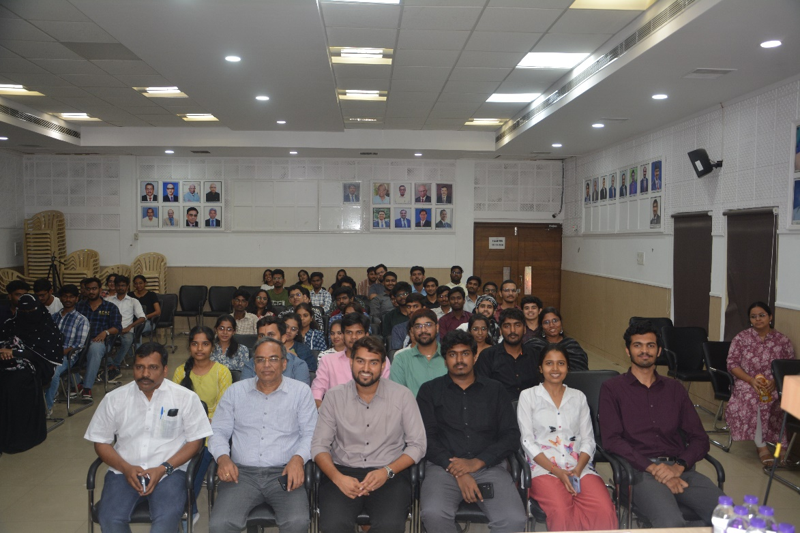

Snapshots from the SICASA Logo reveal day, attended by approximately 80 students, held on 6th April, 2025 at the ICAI Bhavan, Hyderabad.



CONTENTS
S. NO. | PARTICULARS | PAGE NO.
1 | OFFICE BEARERS OF SICASA HYDERABAD 2025- 26 | 2
2 | SICASA HYDERABAD CHAIRMAN’S MESSEGE | 3
3 | SICASA HYDERABADCO-CHAIRMAN’S MESSEGE | 4
4 | APRIL MONTH PHOTO GALLERY | 5
5 | ARTICLE BY STUDENTS | 8
6 | CREATIVE POEM BY STUDENT | 18
7 | INVITATION FOR ARTICLE | 19

Disclaimer:
The Hyderabad Branch of SIRC or SICASA Hyderabad does not accept any responsibility for the views expressed by different contributors. The views and opinions expressed.in the articles are of the author and SICASA Hyderabad is not necessary to agree with the views.

OFFICE BEARERS OF SICASA HYDERABAD 2025-26
C. GOUTHAM SIDDHARTH
SSF CO-ORDINATOR
T. LOKESHWARAO
JOINT SECRETARY ACADAMICS
B. SATYA SAMPAT KUMAR
TREASURER
TALHA YASAR
JOINT SECRETARY EVENTS

PIYUSH KABRA
JOINT TREASURER




SUMANTH VEMURI
VICE-CHAIRMAN
V. V MADHUSREE
SECRETARY




K. NAGA SRITHA
CULTURAL CURATOR


E. NITISH
SPORTS CO-ORDINATOR
K. AASHA SAILU SREE
CREATIVE HEAD

CA. Mukkara Sai Charan Reddy
SICASA CHAIRMAN

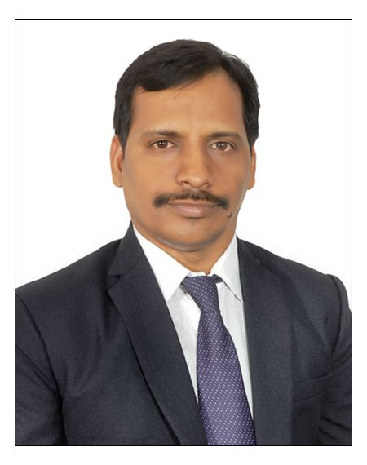
CA. Gonugunta Murali
SICASA CO-CHAIRMAN


STUDENT COMMITTEE MEMBERS 2025-26
SICASA HYDERABAD CHAIRMAN’S MESSEGE
Dear Students,
As I pen down these words in my first message as the Chairman of SICASA Hyderabad, my heart is filled with gratitude, purpose, and a deep sense of excitement. Stepping into this role alongside being elected to the Managing Committee of ICAI Hyderabad, marks the beginning of a journey I hope to make memorable not just for me, but for every student who is part of this ever evolving SICASA family.

They say, “A leader is not the one who leads from the front, but the one who walks beside you when the climb is steep.” This is the kind of leadership I promise to bring to SICASA. A leadership that listens, uplifts, and grows with you.
CA. M. Sai Charan Reddy
Chairman, SICASA Hyderabad

We, the students of this noble profession, are not just preparing for exams. We are shaping the future of India’s financial integrity. Our challenges are many, but so is our potential. I believe that every CA student carries within them a spark, and SICASA will be the wind that helps that spark become a flame.

Let this be the year…
We rise beyond routine.
We embrace excellence over comfort.
We discover strength in community.
We chase knowledge with curiosity and courage.

My vision for SICASA Hyderabad is simple yet powerful: to build a platform that resonates with purpose, inspires self-belief, and creates opportunities for every student to shine. Be it through academics, creativity, leadership, or resilience. SICASA Hyderabad will be your partner, your launchpad, and your constant cheerleader.

As Rumi beautifully said, “Don’t you know yet? It is your Light that lights the world.”
So shine. Loudly. Proudly.

Here’s to a new chapter. Here’s to us.

With heartfelt enthusiasm,

CA. Mukkara Sai Charan Reddy
Chairman, SICASA Hyderabad

SICASA HYDERABAD CO-CHAIRMAN’S MESSEGE
Dear Students,

As I step into the role of Co-Chairman of SICASA Hyderabad, I do so with immense pride, humility, and a strong sense of responsibility. It is not just a title—it is a promise. A promise to walk with you, grow with you, and to make SICASA not just a student body, but a movement of purpose, passion, and progress.

To be a part of SICASA is to be part of something bigger than ourselves. It’s where ideas come alive, talents are discovered, and leaders are nurtured. Being elected as Co-Chairman
In this vibrant phase is both an honor and an opportunity—one I intend to use to serve, support, and spark change.
CA. Gonugunta Murali
Co-Chairman, SICASA Hyderabad

In every classroom, in every late-night study session, and in every moment of self-doubt, remember this: you are not alone. SICASA is here for you—to amplify your voice, to celebrate your achievements, and to help turn your ambitions into actions.

Together with our dynamic Chairman and the ever-passionate Managing Committee, we are committed to creating a SICASA that is more inclusive, impactful, and inspiring than ever before.

Let us build a culture that celebrates:
Curiosity over conformity
Courage over comfort zones
Collaboration over competition
And most importantly, let’s build each other up.

Let this term be the one where you step forward, try something new, and let your light be seen. Whether through academics, art, leadership, or ideas—you have something to give. And we’re here to make sure it gets the spotlight it deserves.

Together, let's make this journey unforgettable.

With energy and hope,

CA. Gonugunta Murali
Co-Chairman, SICASA Hyderabad

April monthPHOTO GALLERY
Snapshots from the Logo Reveal day, held on 6th April 2025 at ICAI Bhavan, Hyderabad, with participation from students and volunteers.
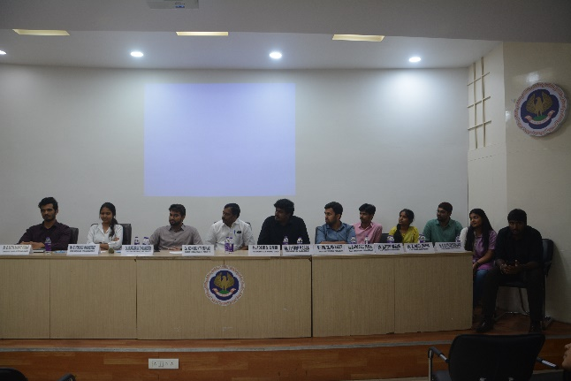

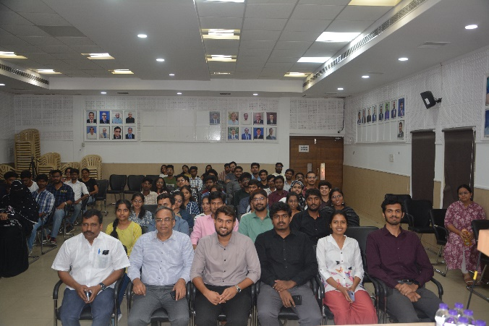
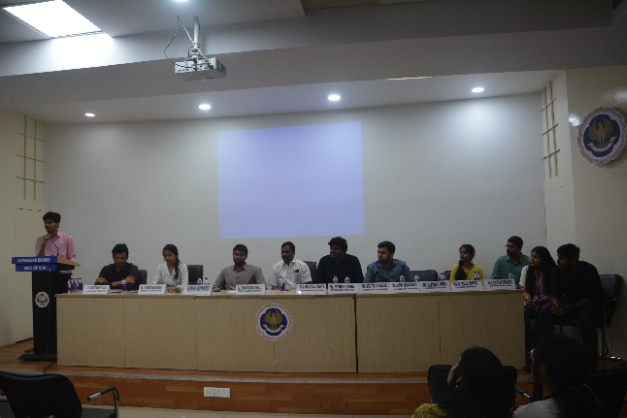


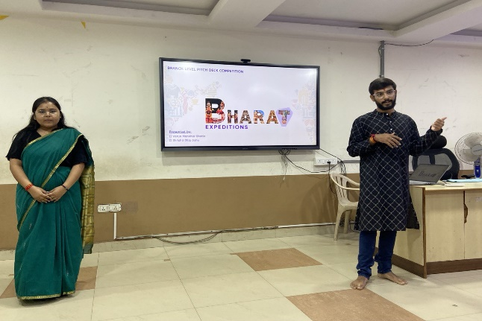

Snapshots from National Talent Search Competition, where participants have come, held on 13thApril, 2025 at ICAI Bhavan, Hyderabad.

Snapshots from the CA-Final, CA-Inter & CA Foundation, held from1st April, 2025 to 23rd April, 2025 at the ICAI Bhavan, Hyderabad.
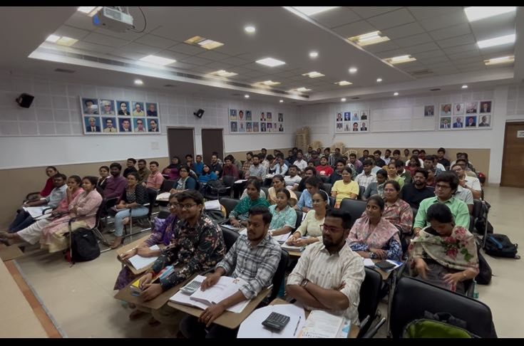
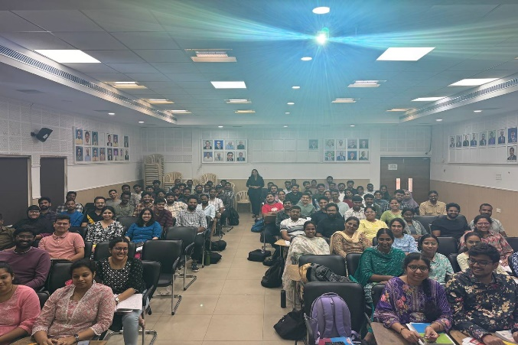
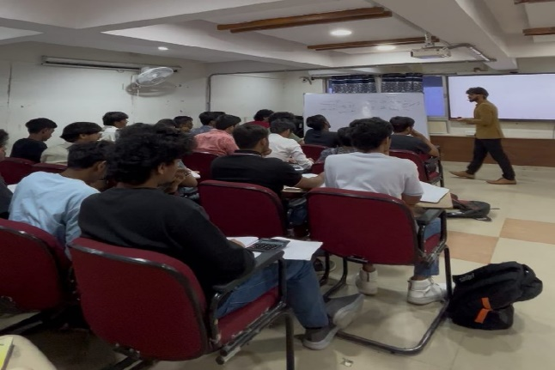


ARTICLE BY STUDENT-1

Green Taxation: Paving the Path to Sustainable Development

Introduction
In the face of accelerating climate change, rising pollution levels, and unsustainable resource consumption, green taxation has emerged as a vital fiscal policy tool to promote environmental sustainability. Also known as eco-taxation or environmental tax, it is a means to correct environmental externalities, shifting the burden of pollution and ecological damage back to the polluters.
As Mahatma Gandhi wisely said, “The earth provides enough to satisfy every man’s needs, but not every man’s greed.” Green taxation aims to restore this critical balance between economic growth and ecological integrity.

I. What is Green Tax?
Green tax refers to levies imposed on goods and activities that harm the environment. These taxes are based on the “polluter pays” principle, compelling industries and individuals to bear the true cost of environmental damage.

II.How is It Computed?
Green taxes can be computed in several ways, depending on the environmental metric in focus:
(i). Carbon Tax: Based on the amount of carbon dioxide (CO₂) emitted. For instance, a per-tonne rate is charged on greenhouse gas emissions.
(ii). Fuel Taxes: Imposed per litre based on fuel type, with higher rates for more polluting fuels like diesel.
(iii). Vehicle Green Tax: Computed based on the age of the vehicle, fuel type, and level of emissions. Older vehicles pay higher tax.
(iv). Plastic Waste Taxes: Based on the weight or volume of non-recyclable plastic packaging.
The idea is simple: “The more you pollute, the more you pay”

III.Need for Green Taxation
India, with its burgeoning population and rapid industrialization, faces severe environmental stress. According to a World Bank report, air pollution alone costs India nearly 8.5% of its GDP annually. Climate events like floods, heat waves, and droughts are becoming more frequent.
Thus, green taxation becomes a necessary policy imperative to:
1. Internalize environmental costs.
2. Promote cleaner alternatives.
3. Raise funds for environmental protection.

IV.Essence of Green Taxation
The essence of green taxation lies in making environmental harm economically expensive. It incentivizes greener behavior and encourages innovation in cleaner technologies. Governments can reinvest these revenues into renewable energy, sustainable transport, and afforestation.
As former UN Secretary-General Ban Ki-moon said, “There is no Plan B because there is no Planet B.”

V.Steps Taken by India
India has already initiated several steps in line with green taxation principles:
1.Green Tax on Older Vehicles: In 2021, the Ministry of Road Transport announced green tax on vehicles older than 15 years for personal use and 8 years for commercial use.
2.Carbon Pricing Initiatives: Though India has not implemented a direct carbon tax, it levies a clean energy cess on coal at ₹400 per tonne.
3.Goods and Services Tax (GST) Exemptions: Renewable energy devices and services attract only 5% GST, compared to 28% on luxury goods.
4.Faster Vehicle Scrap page Policy: Aims to phase out polluting vehicles and reduce urban emissions.
5.National Hydrogen Mission & Solar Initiatives: Encouraging green energy through incentives and low taxation rates.

VI.Challenges in Implementing Green Taxation
Despite its promise, green taxation in India faces several roadblocks:
1. Political resistance to fuel price hikes.
2. Potential regressive impact on low-income households.
3. Difficulty in emission measurement and compliance.
4. Industry pushback, especially from coal, automotive, and manufacturing sectors.
5. Lack of administrative capacity to monitor and implement green taxes effectively.

VII.Conclusion
Green taxation is not just an economic tool; it is a moral and ecological necessity. By embedding the cost of environmental harm into market prices, it encourages behavior change and funds sustainable development.
As economist Nicholas Stern said, “Climate change is the greatest and widest-ranging market failure ever seen.” Green taxation helps fix this failure fairly and efficiently.

VIII.Way Forward: Green Taxes as a Pillar of Sustainability
To maximize the benefits of green taxation, India must adopt a balanced and inclusive approach:
1. Progressive Tax Design: Higher taxes on luxury pollutants and lower burden on essential services.
2. Revenue Recycling: Use proceeds for green jobs, clean energy, and subsidies for the poor.
3. Integration with ESG Policies: Embed green tax incentives into corporate governance and finance.
4. Public Awareness Campaigns: Help citizens understand the environmental and health benefits.
5. Global Coordination: Harmonize green tax rates across borders to avoid trade distortions.
India’s commitment to net-zero emissions by 2070 requires fiscal courage. Green taxation, if thoughtfully implemented, can be the foundation for a greener, cleaner, and more resilient future.


Shrinithy S.S
SRO0708102
Coimbatore
ARTICLE BY STUDENT-2

Beyond the Bank: Unlocking Unique Paths to Acquisition Financing

In today’s dynamic business environment, acquisition financing plays a pivotal role in enabling companies to scale operations, diversify portfolios, and gain competitive advantages. Whether you’re an entrepreneur, finance student, or business strategist, understanding how acquisition financing works is essential to grasping modern business expansion.

What is Acquisition Financing?

Acquisition financing refers to the capital secured specifically to purchase another business. It provides immediate liquidity to facilitate such transactions, allowing the acquiring company to leverage the strengths, resources, or market position of the target firm. This financial strategy is common in sectors looking to achieve growth through consolidation or expansion.

Let’s now explore the unique sources of acquisition financing—those tailored specifically for funding acquisitions and not commonly used for regular business operations.

1. Leveraged Buyout (LBO)

A leveraged buyout uses a substantial amount of borrowed money to acquire a company. The assets of the target company are often used as collateral. This method allows the acquirer to minimise its own capital investment while maximising the potential return on equity.

2. Mezzanine Financing

Mezzanine financing is a hybrid of debt and equity, generally subordinated to senior debt but offering equity-like returns. It’s often used when the acquirer needs additional flexibility in repayment and is willing to offer a share in future upside through warrants or convertibles.

3. Seller Financing

In seller financing, the seller agrees to accept a portion of the purchase price over time. This creates a win-win where the buyer reduces upfront capital requirements and the seller remains invested in the company’s continued performance. It is particularly common in private and SME transactions.

4. Stock Swap (Equity Exchange)

Rather than paying in cash, the acquiring firm offers its own stock to the shareholders of the target company. This preserves cash reserves and may offer tax benefits. Stock swaps are often used in strategic mergers where both companies benefit from synergies.

5. Earn-Out Agreements

Earn-outs involve structuring the deal so that part of the payment to the seller depends on the future performance of the acquired business. This reduces risk for the buyer and provides a performance-based incentive for the seller, especially in industries with uncertain cash flows.

6. Private Equity and Venture Capital Backing

In larger acquisitions or those involving start-ups and turnarounds, private equity or venture capital firms often fund or facilitate the acquisition. These investors not only provide capital but also strategic oversight, helping to improve operations post-acquisition.

7. Special Purpose Acquisition Company (SPAC)

SPACs are entities created solely to raise funds through an IPO with the intent to acquire another company. They have become an increasingly popular route to fund acquisitions, especially in the tech and innovation-driven sectors.

8. Bridge Loans

Bridge financing offers short-term capital to close a deal quickly while waiting for long-term funding. It is often used in time-sensitive acquisitions where strategic timing is critical.

Conclusion

Acquisition financing is more than just arranging funds—it’s about strategically structuring capital to align with business goals and deal dynamics. While traditional funding sources serve general business needs, acquisition financing relies on unique and specialised tools such as LBOs, mezzanine capital, and stock swaps.
A well-planned financing structure ensures not only the success of the acquisition but also the stability and growth of the business post-transaction. Understanding and leveraging these unique sources empowers businesses to pursue expansion opportunities with confidence and foresight.


Shobhit Pandey
CRO0649283
Varanasi

Taxation in the Digital Economy: Netflix to Google, who pays what?

In the digital era, where everything is available at a tap of a screen, the taxation system struggles to evolve as fast as the businesses. India’s taxation system was originally designed to tax tangible goods and traditional services. But in today's fast-moving digital economy, this system is struggling to keep up with digital transactions.
In a world where entertainment is streamed, groceries are delivered at your doorstep and our digital footprints follow us everywhere and apps use algorithms to understand the users’ preferences, the global giants like Blinkit, Instagram, and YouTube earn millions of revenue without having physical goods and services the big question is: How are they taxed? Are they paying taxes inIndia?
- The Problem here is traditional tax rules:
- Old tax rules = taxation of physical goods and services
- But these big giants have “Virtual presence” and not physical presence in India yet earning millions of dollars of revenue
- A study conducted by Broad India Forum states that money spent on apps is going to around USD 800 Billion by 2030
- The amount of revenue generated by Netflix is $39 Billion in 2024, but it is a US based company
- India’s response to who’s paying what?
- In the year 2016: 6% Equalization Levy was levied on online advertising services (affects Instagram, Google)
- In the year 2020: 2% was levied on e- commerce transactions (affects Amazon, Play store)
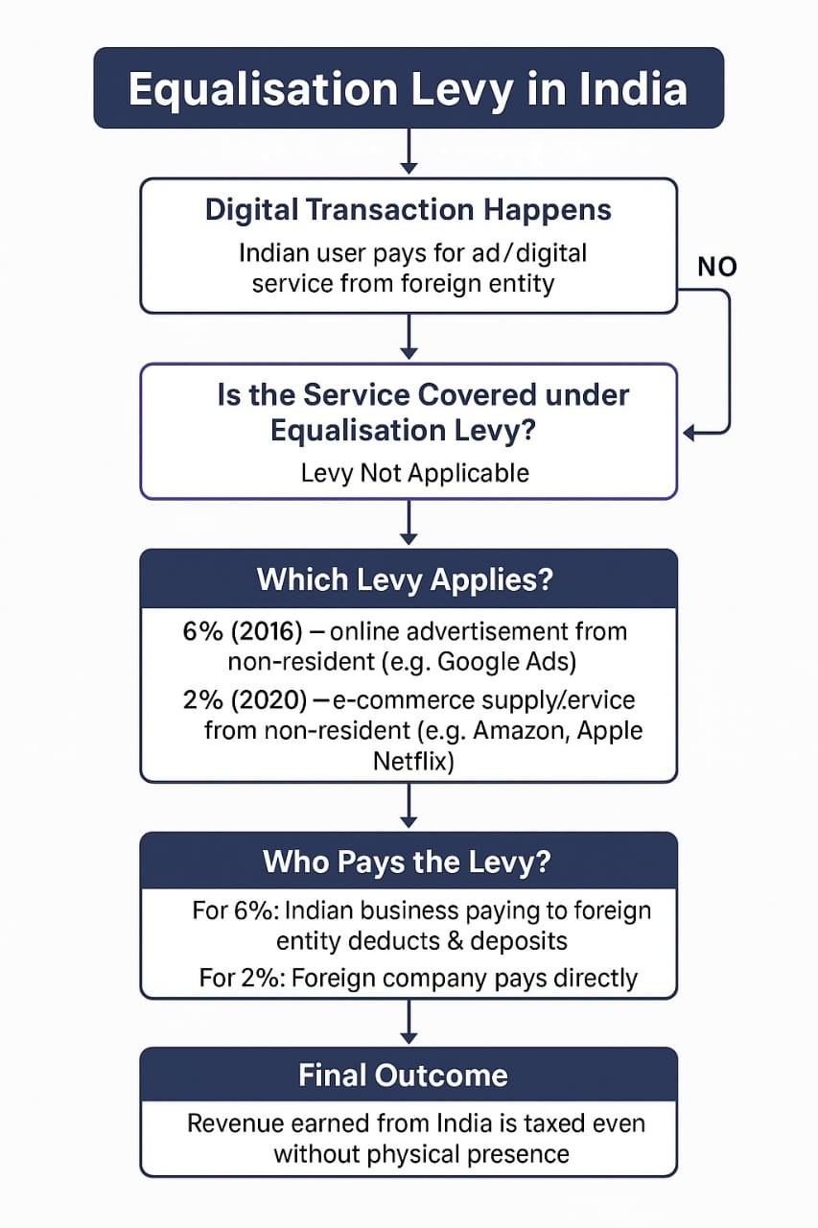
- Global Push for Digital Taxation
  - The Organization for Economic Co-operation and Development (OECD) has been leading multilateral negotiations to create a standardized global approach to taxing the digital economy.
  - In 2021, the OECD brokered a historic agreement backed by over 140 countries, structured into two pillars.
Pillar One: Reallocation of Profits
  - Targets the largest and most profitable multinational enterprises (MNEs) (those with global turnover above €20 billion and profitability above 10%).
  - A portion of their profits (about 25% of profit above the 10% threshold) will be reallocated to market countries—i.e., where users and consumers are located, regardless of physical presence.
  - This is meant to address digital companies like Google, Facebook, and Netflix that earn billions in foreign markets without having a traditional business base there.
Pillar Two: Global Minimum Tax
  - Establishes a minimum effective corporate tax rate of 15% for multinational companies with revenues above €750 million.
  - Aims to end the “race to the bottom” in corporate tax rates and ensure companies pay a baseline level of tax wherever they operate.
  - Expected to generate around $150 billion in global tax revenues annually.
- Challenges Ahead,
  - Hard to value user data
  - Risk of double taxation or disputes with foreign countries
  - Digital economy evolves faster than tax laws

- Conclusion
The way big tech companies like Google and Netflix are taxed is changing. Governments around the world want these companies to pay their fair share, especially when they make money from users in countries where they don’t even have offices.
Through global efforts, like the OECD’s plan for a fairer tax system, countries are working together to fix this. While it’s still a work in progress, the goal is clear: to make sure digital companies pay taxes just like everyone else—wherever they earn money.


Leena S Chourdia
SRO0756083
Hyderabad

CREATIVE CORNERPOEM
The Magic You Are Looking For Is in the Work You Avoid

It’s all about the breeze—
That gentle push at dawn’s first light,
The one that makes you feel something within,
And makes you think, maybe today.

You wait for that time to lift you high,
A miracle wind to help you fly,
But magic’s not in standing still—
It’s born from sweat and will.

You fear the climb, the uphill track,
Avoid the work, then wonder back—
Why dreams stay locked, why winds don’t turn,
Why passion fades, and hopes don’t burn.

But hear me out—the truth is plain,
The breeze you seek comes through the pain,
From hands that build and hearts that fight,
From daring steps into the night.

So stop just waiting for the wind—
Face the work you’ve left behind.
The magic’s there, where fear resides—
In every step your heart denies.

KAMESHWARAN O M
SRO0783229
BENGALURU

INVITATION FOR ARTICLE

SICASA Hyderabad is inviting articles for E-Newsletter: INSIGHT for the month of June 2024. All the students who want to get featured can submit their articles, artworks, poems, and short stories etc. which are related to Chartered Accountancy curriculum for our further newsletters.
Send us your works on:sicasahydnewsletter@gmail.com

Last Date for Submission:10thApril, 2025.

Rules:
- No word limit but the articles shall be confined to topic opted.
- Article should be sent in word document only.
3. No plagiarism allowed; content sent should be original.
4. Send your works to the mail with the following attachments:
- Your work
- Full name along with student registration number & firm name
- Passport photo
- Contact details.
- Subject of email must contain the details of your work
(E.g., Article/Artwork etc.)

