

NEWSLETTER- September 2025
SAARATHI
~THE VOICE THAT LEADS~

Hyderabad BRANCH OF SIRC OF ICAI
&
HYDERABAD BRANCH OF SICASA
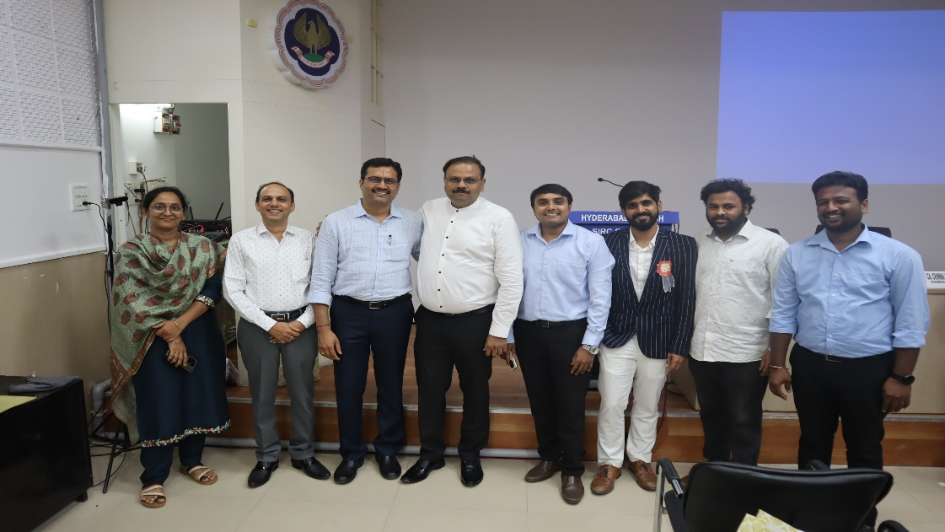

Snapshot from the Teachers day Celebration on5th of Septermber 2025 at the ICAI Bhavan, Hyderabad.

CONTENTS

Disclaimer:
The Hyderabad Branch of SIRC or SICASA Hyderabad does not accept any responsibility for the views expressed by different contributors. The views and opinions expressed.in the articles are of the author and SICASA Hyderabad is not necessary to agree with the views.

S. NO. | PARTICULARS | PAGE NO.
1 | OFFICE BEARERS OF SICASA HYDERABAD 2025- 26 | 2
2 | SICASA HYDERABADSPORTS COORDINATORMESSAGE | 3
3 | SICASA HYDERABADCULTURAL CURATOR MESSAGE | 4
4 | SEPTEMBER MONTH PHOTO GALLERY | 5
5 | KNOWLEDGE CORNER | 7
6 | CREATIVE BUNCH | 10
7 | INVITATION FOR ARTICLE | 15

OFFICE BEARERS OF SICASA HYDERABAD 2025-26
C. GOUTHAM SIDDHARTH
SSF CO-ORDINATOR
T. LOKESHWARAO
JOINT SECRETARY ACADAMICS
B. SATYA SAMPAT KUMAR
TREASURER
TALHA YASAR
JOINT SECRETARY EVENTS

PIYUSH KABRA
JOINT TREASURER

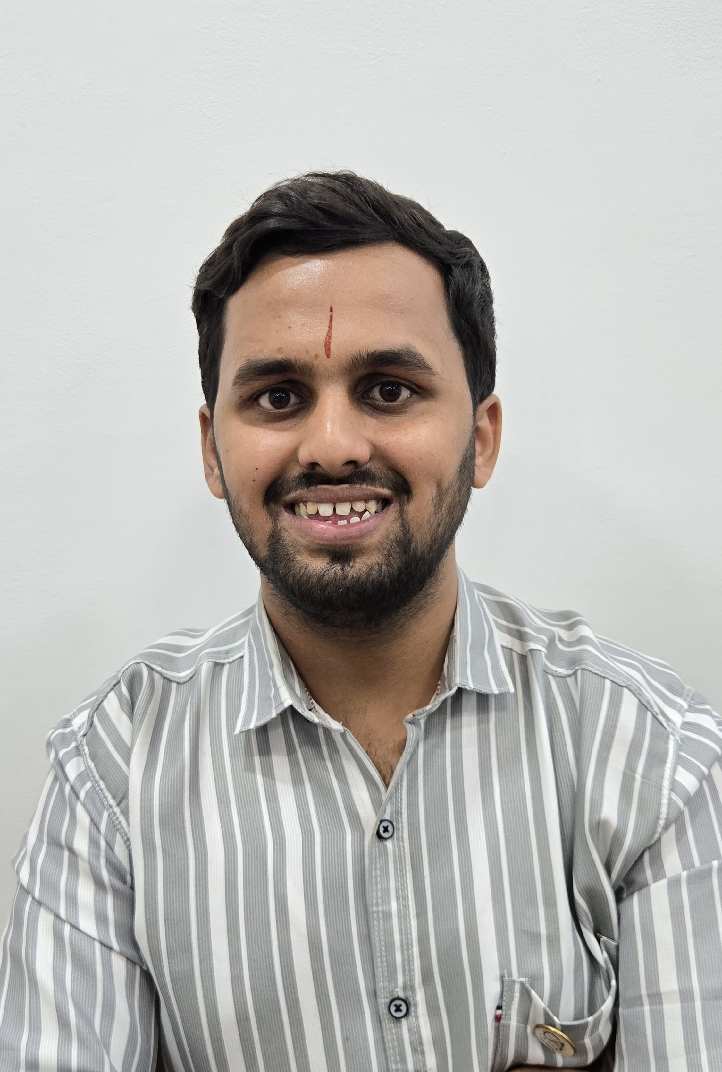
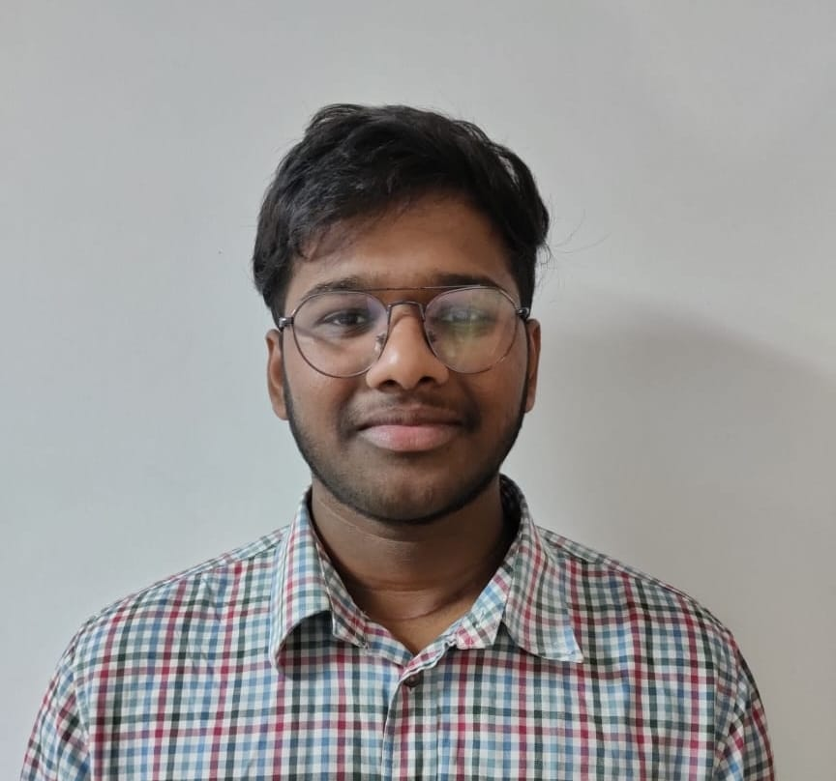
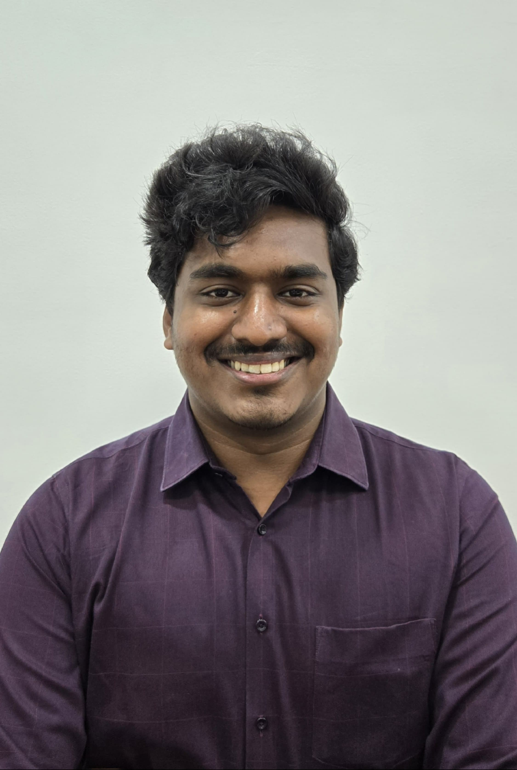
SUMANTH VEMURI
VICE-CHAIRMAN
V.V MADHUSREE
SECRETARY
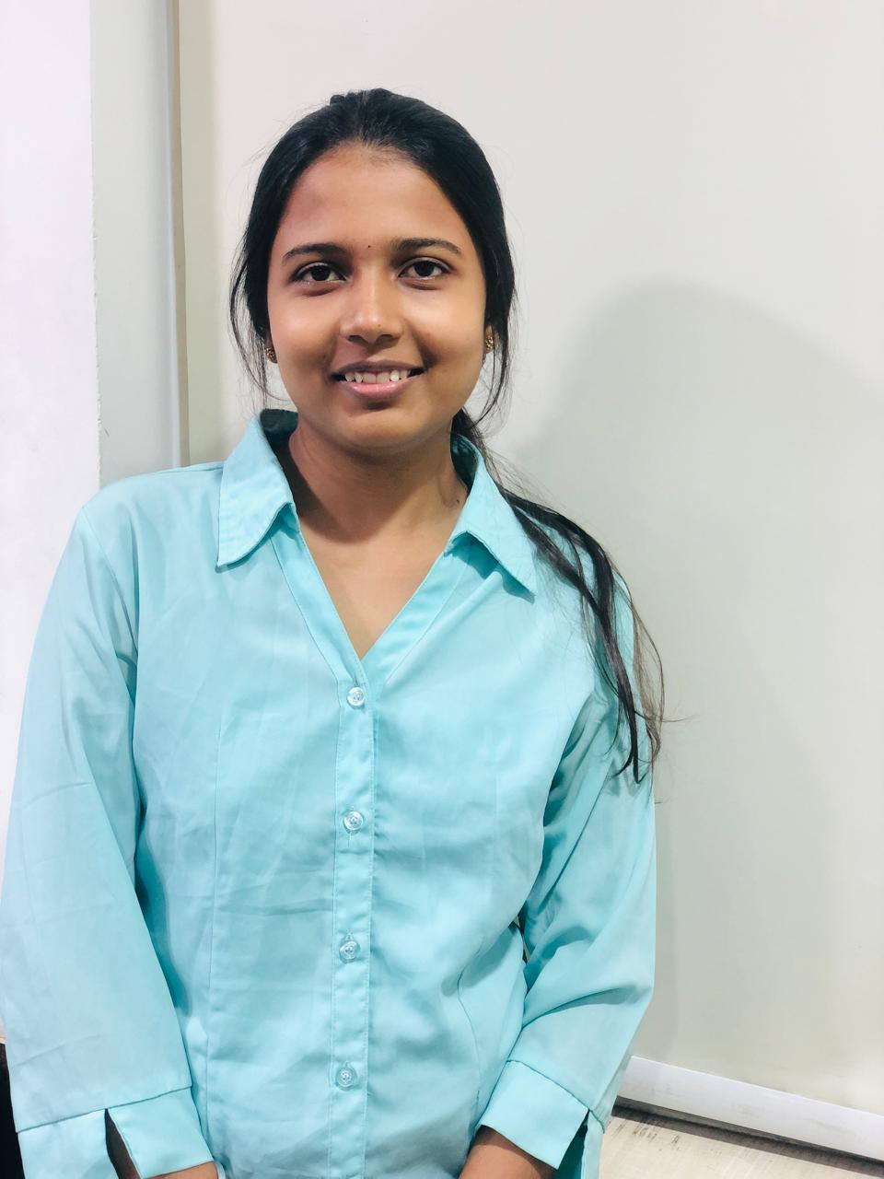
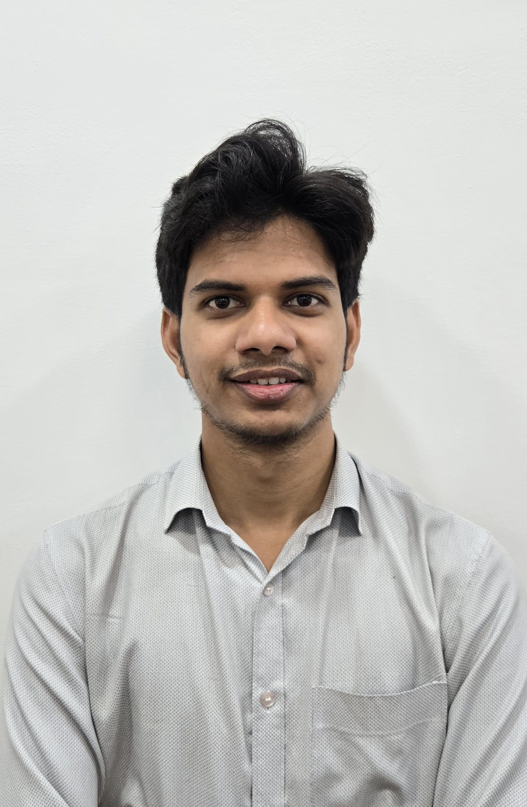
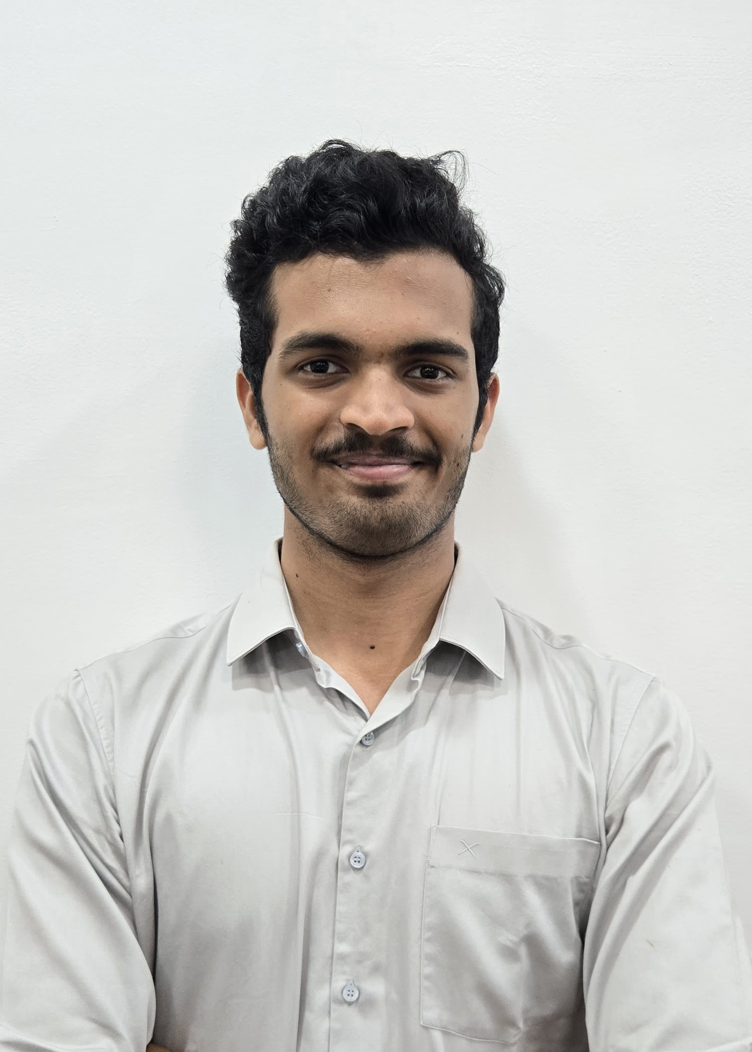
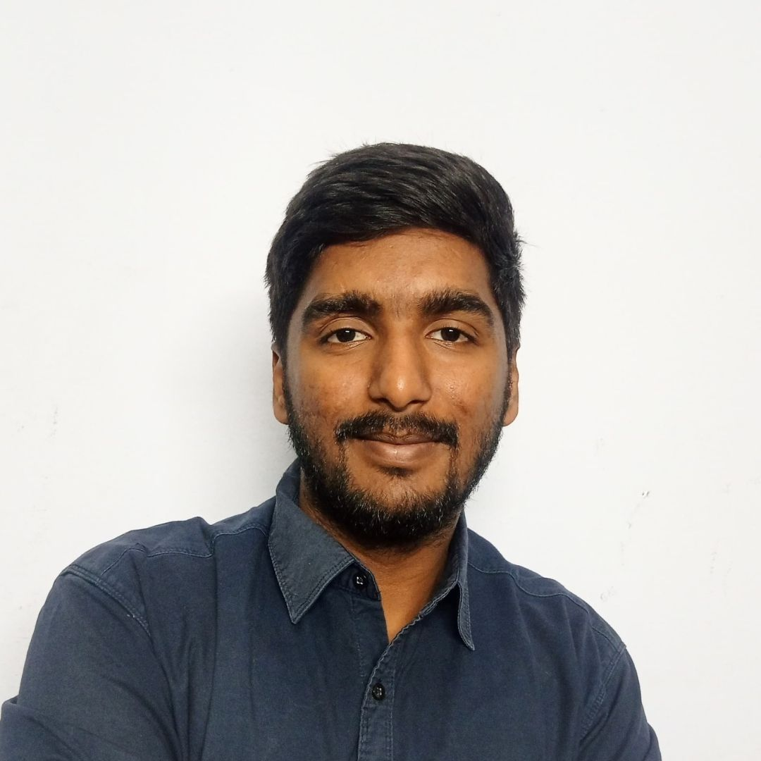
K. NAGA SRITHA
CULTURAL CURATOR
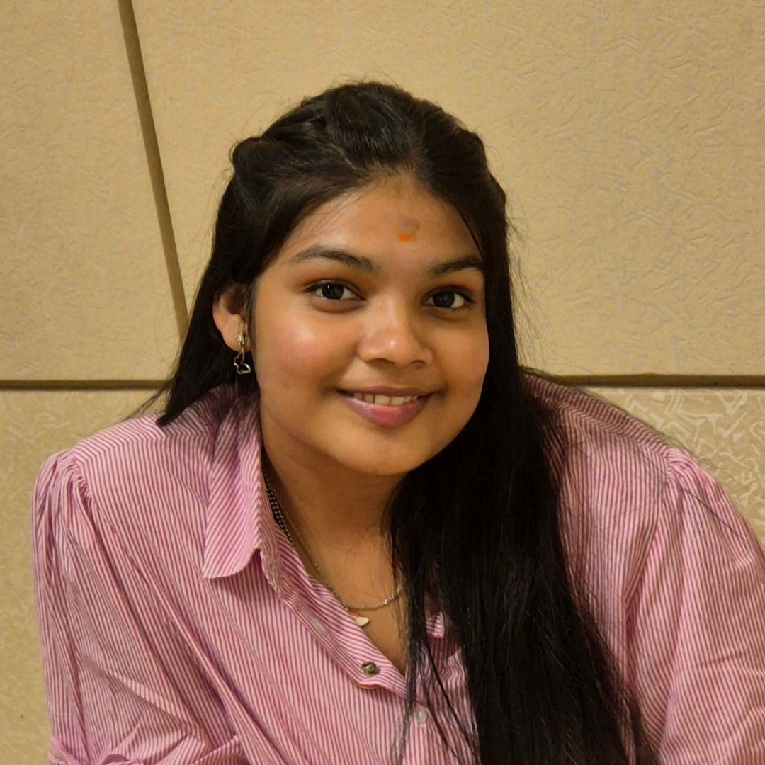
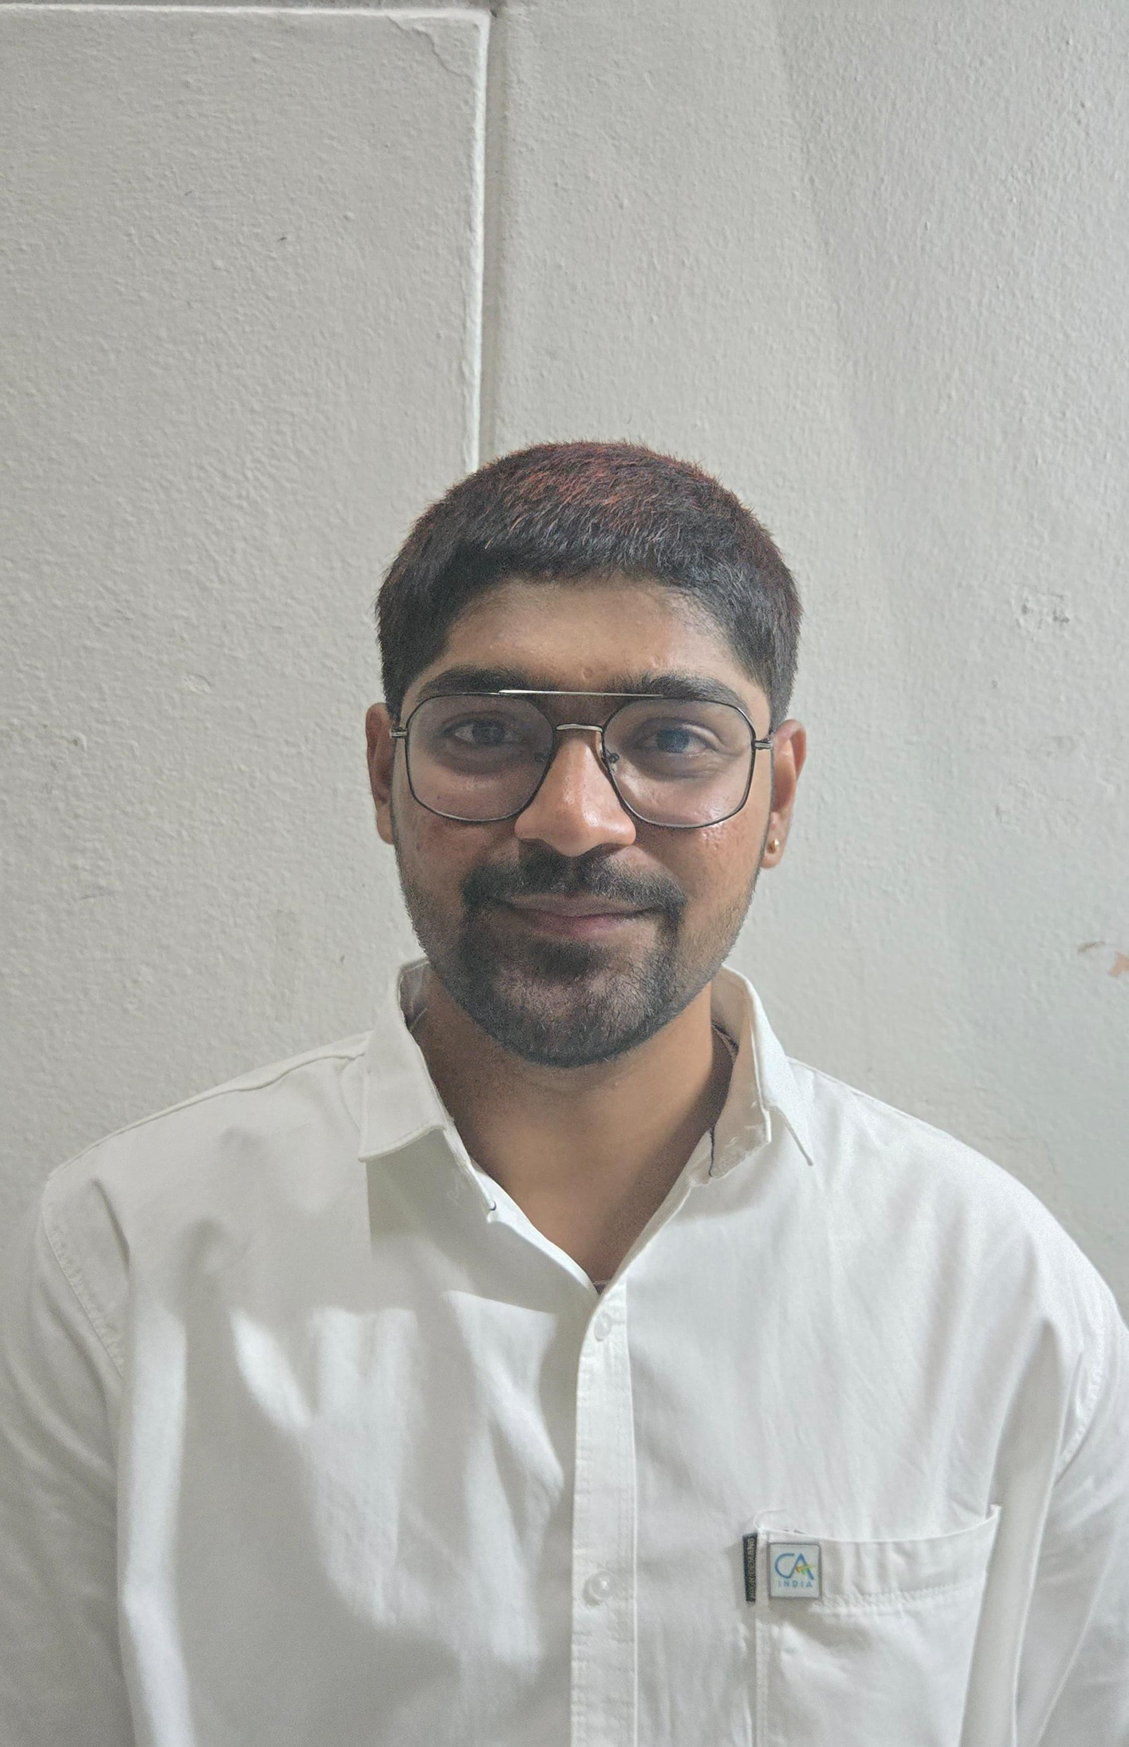
E. NITISH
SPORTS CO-ORDINATOR
K. AASHA SAILU SREE
CREATIVE HEAD
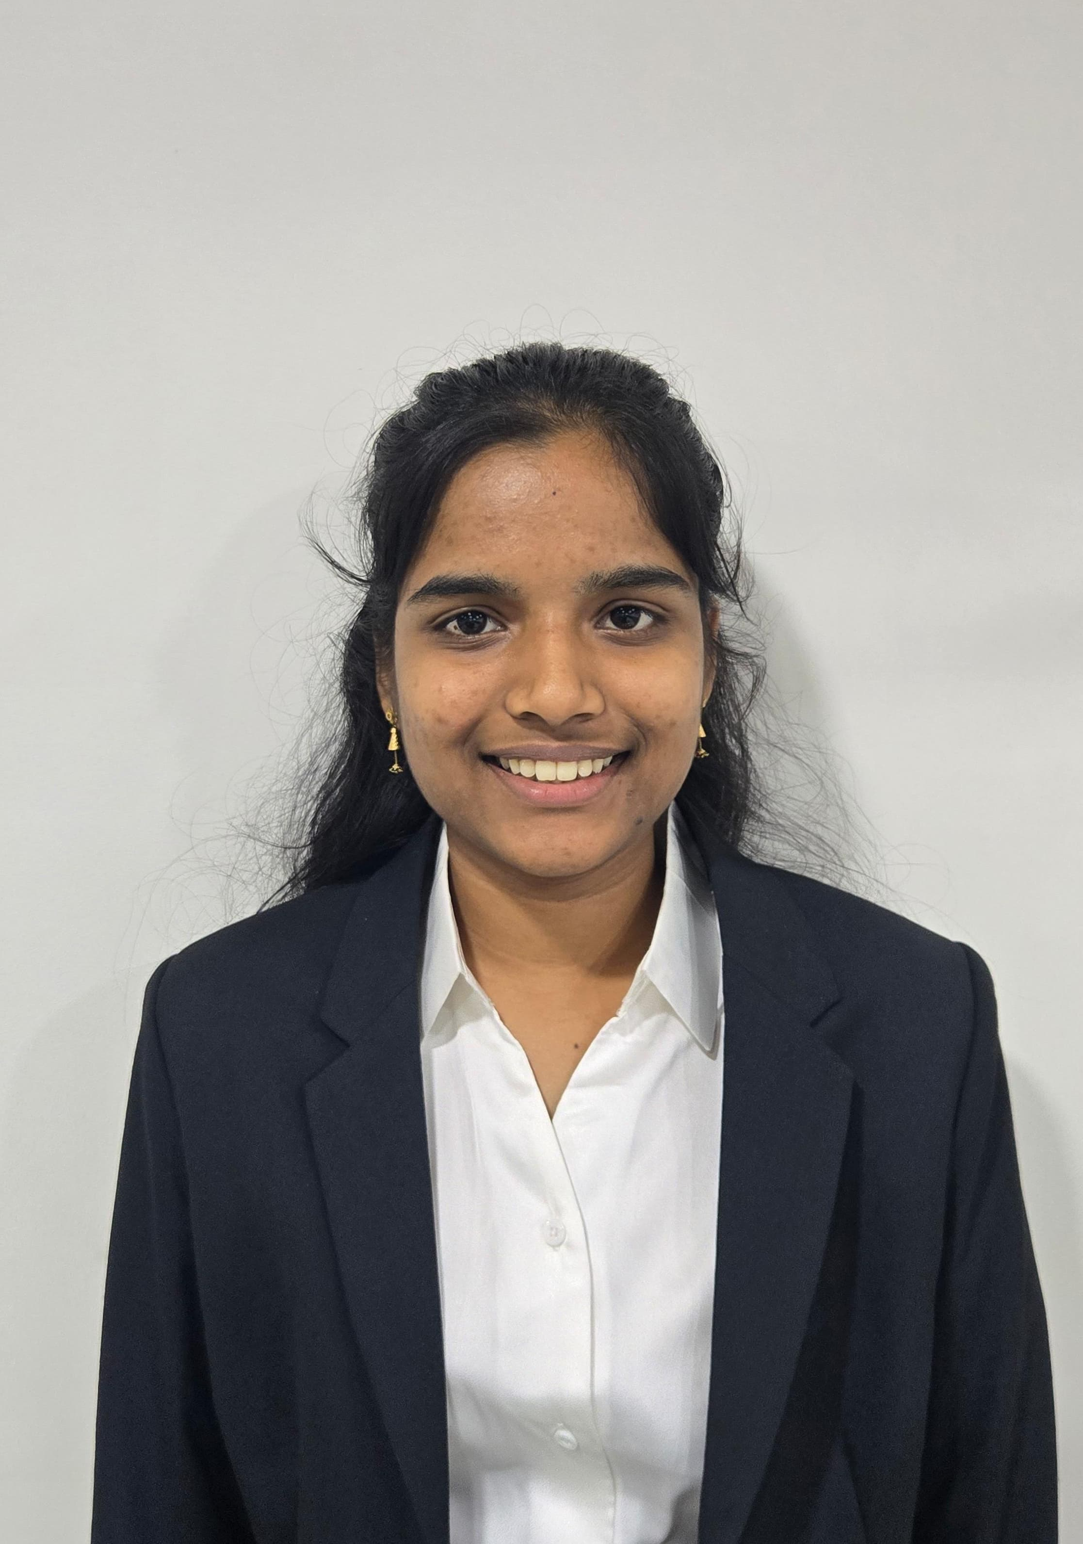
CA. Mukkara Sai Charan Reddy
SICASA CHAIRMAN

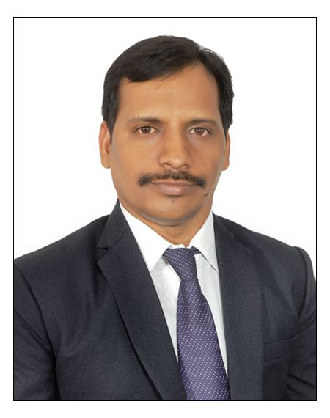
CA. Gonugunta Murali
SICASA CO-CHAIRMAN

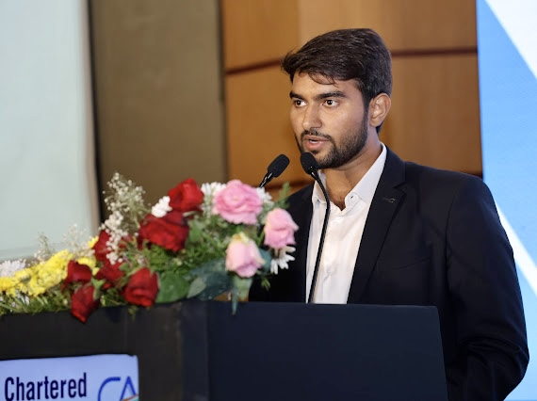
STUDENT COMMITTEE MEMBERS 2025-26
SICASA HYDERABADJOINT SECRETARY-ACADEMICSMESSAGE
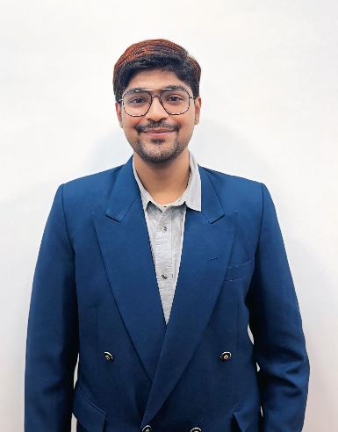

Dear Fellow Sports Enthusiasts,
It is with great enthusiasm and a deep sense of pride that I reach out to all of you as the Sports Coordinator for SICASA Hyderabad. Being a part of this esteemed association has been an incredible journey — one filled with opportunities to learn, grow, and collaborate. As a community, we have always strived to not only excel academically but also embrace the holistic development that sports provide.
For many of us, sports are more than just a pastime. They are a reflection of the values we uphold — teamwork, resilience, discipline, and the drive to constantly push our limits. The energy and camaraderie that we experience during every match, event, or practice session are what bind us together as a family within SICASA. These moments not only build our bodies but also shape our minds, teaching us lessons that go far beyond the field.
In my role as your Sports Coordinator, my mission is to create a platform where every student can find their passion, be it through competitive sports, casual games, or fitness activities. Whether you're someone who dreams of representing SICASA at regional tournaments or someone who simply enjoys playing for fun, there is a space for everyone.
Over the course of this term, I envision a few key objectives:
1. Regular Sports Activities: Organising inter-class and intra-class competitions across various sports to ensure everyone has the chance to participate and showcase their skills.
2. Wellness Initiatives: Bringing awareness to the importance of physical health, from fitness sessions to mental wellness workshops — because a healthy body supports a sharp mind.
3. Team Building & Networking: Sports are about more than just competition — they’re about building connections, working together, and learning from each other’s strengths.
4. Inspiring Leadership: Through sports, I hope to foster leadership qualities that will benefit us in every walk of life, both as students and as future professionals.
Together, let's make SICASA Hyderabad not only a hub of academic brilliance but also a place where every student feels empowered, motivated, and inspired to be their best — both in the classroom and on the field.
As we set our sights on this term, I encourage each of you to step forward, participate, and contribute to our collective sporting journey. Whether you're an athlete, a coach, a supporter, or a volunteer, your involvement will help shape SICASA’s legacy as a dynamic, inclusive, and energetic community.
Sports teach us that no victory is truly sweet without the effort, unity, and spirit of collaboration behind it. Let's bring this mindset to SICASA Hyderabad, creating a community where we grow stronger together, on and off the field.

E NitishVerma
Sports Coordinator,
SICASA Hyderabad

SICASA HYDERABAD CULTURAL CURATORMESSAGE
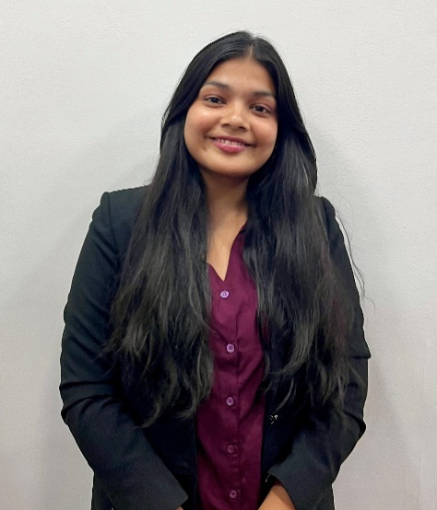
It gives me immense pleasure to share a few words as the Cultural Curator of SICASA Hyderabad. Culture is more than just events or celebrations — it is the essence of who we are. It reflects our creativity, our ability to collaborate, and the spirit of unity that binds us together. At SICASA, we strive to build a platform where every student’s talent finds a stage, every idea contributes to our collective vibrancy, and everyone feels a sense of belonging.

As Cultural Curator, my mission is to create opportunities for participation, to celebrate the diversity of our community, and to nurture an environment where every individual feels encouraged to express themselves. Through thoughtfully planned events, fests, and cultural initiatives, I aim to showcase talent, foster teamwork, and strengthen the bonds that make our community unique. Each activity is designed not only to entertain but to inspire, to teach, and to bring people closer.

Culture, in its truest form, teaches us lessons beyond academics. It encourages us to step out of our comfort zones, to take initiative, and to collaborate with peers who bring different perspectives and experiences. Every rehearsal, performance, and celebration is a chance to grow — to develop confidence, empathy, leadership, and adaptability. These experiences shape us into well-rounded professionals and compassionate individuals, ready to take on the challenges of the world.

I believe that every student has something valuable to offer. Whether it is music, dance, drama, art, writing, or any form of creative expression, SICASA Hyderabad is a space where your passion can be nurtured, shared, and celebrated. Participation is not just about performing; it is about learning, connecting, and leaving a lasting impact on our community. By coming together, contributing ideas, and supporting one another, we create memories and experiences that go far beyond the classroom.

This year, let us make every cultural event a celebration of creativity, inclusion, and unity. Let us recognise and honour every talent, value every idea, and make each moment meaningful. Together, we can transform SICASA Hyderabad into a vibrant hub where culture thrives, connections deepen, and every student feels empowered to shine.

I am excited to work alongside all of you to bring this vision to life and make this year one of inspiration, growth, and unforgettable experiences. Let us embrace creativity, celebrate diversity, and build a community that is as dynamic and extraordinary as each one of its members.

K Naga Sritha
Cultural Curator,
SICASA Hyderabad

PHOTO GALLERY
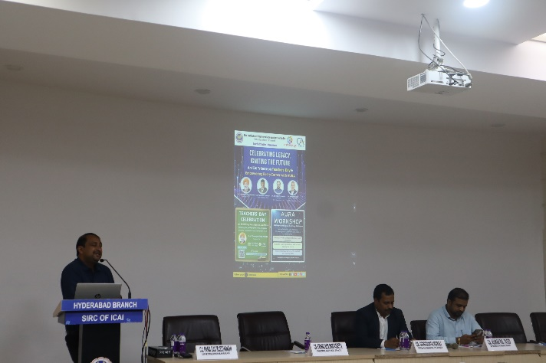
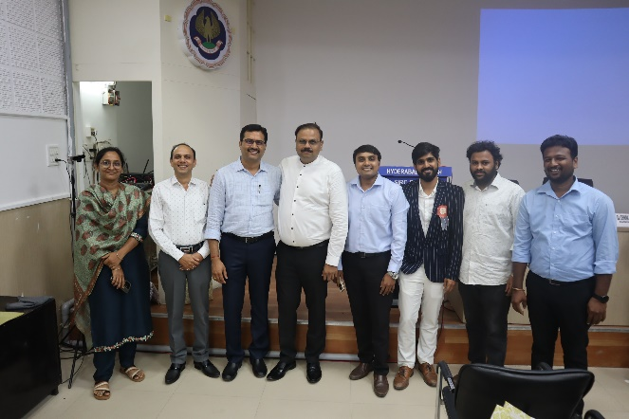
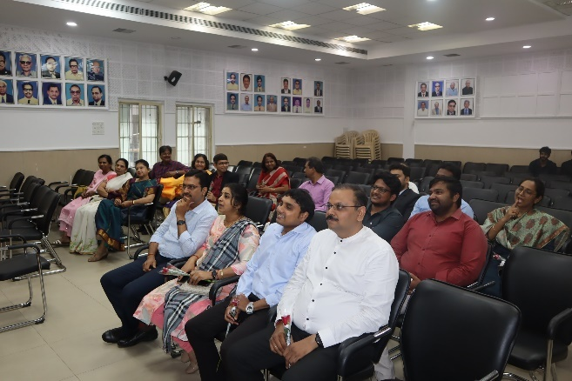
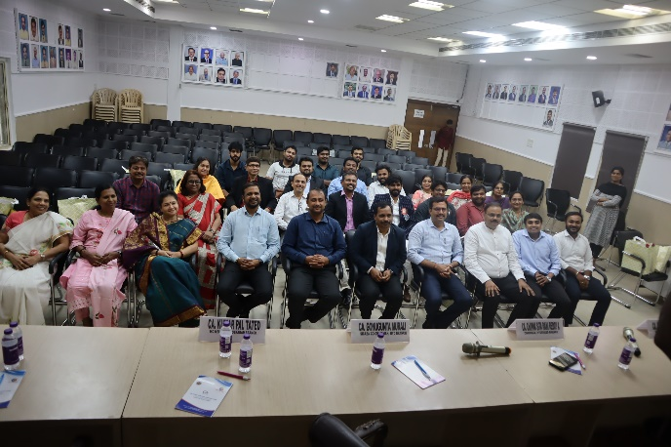
Snapshot from theTeachers day Celebrations on5thSeptember 2025, at ICAI Bhavan, where various CA faculties have attended.
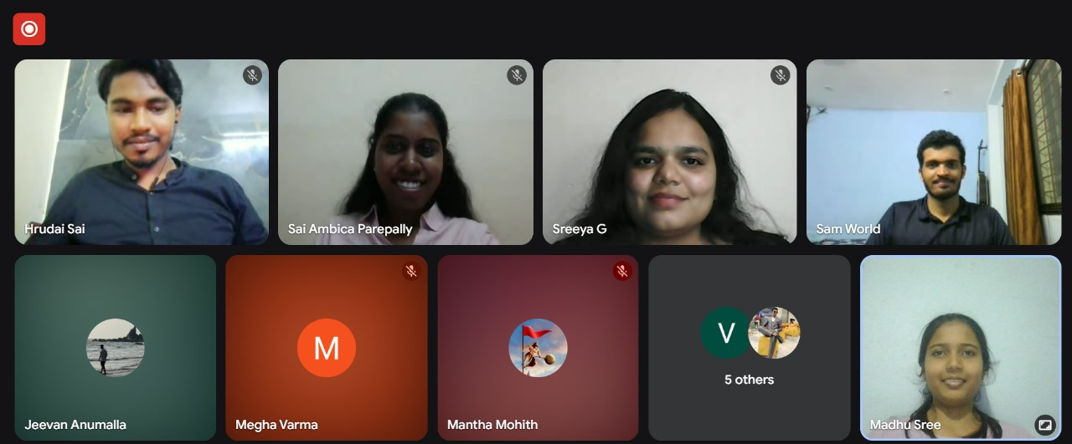
Snapshots from the CA Industrial Training Webinar, held on 13th September, 2025 where 50+ Participants has attended
Snapshots from the CA Industrial Training Webinar, held on 20th September, 2025 where 50+ Participants has attended

KNOWLEDGE CORNER
Dream Big and Excel in Life
As DrA.P.J. Abdul Kalam said,“Dream is not that which you see while sleeping, it is something that does not let you sleep.
Understanding Your Dreams
Dreams are unique to everyone—whether wealth, knowledge, fame, family, travel, or peace—and it's important not to let circumstances or others define what those dreams should be. Personal reflection is essential. Ask if your current ambitions truly align with your inner desires, and stay open to exploring new experiences rather than limiting yourself to what’s familiar.​
The Value of Time in Achieving Dreams
“The time you waste today is the distance between you and your dreams tomorrow”. Making conscious choices about time and actions is the foundation for any achievement in life.
Being Present and Observant
Creating space in daily life (physically, mentally, and emotionally) allows for deeper observation and awareness. This practice helps recognise opportunities and fosters growth beyond previously known boundaries.​
Secrets and Tools for Success
Being in this fast-paced world where attention span is less, especially for our younger generation, the practices to achieve success are:
- Conquer Your Mind First
- Recognise that overthinking will not give solutions, but efforts definitely do.
- Don’t focus on uncontrollable elements.​
- Determine whether FOMO (Fear of Missing Out), doom scrolling, and information overload arebarriers to clarity and creative thinking.
- Come out of being a victim mindset(attention-seeking, excuses, complicating situations), and transform to being proactive.
- Reflecting on your inner self through meditation or any other hobbies you love.

- Solution-Focused Thinking
Smart work with clear and structured planning, rather than excuses and complications,speeds up progress. Accepting failures and learning from them is important.

- Building Extreme Self-Belief
- The most important thing is to believe that our dreams that not impossible.
- Being fearless and shameless in the pursuit of goals creates opportunities. Emotions should be balanced with facts.
- Disassociate from negative influences, even if they are close relations, and enforce strict boundaries for personal growth.​
- Life has already reserved us with the best; avoid unhealthy comparisons with others.​
- Building Your Support Network
- The environment expands the perspectives and thinking, so place yourself in nurturing communities and with aspirational people.
- Connecting with mentors and collaborators who offer wisdom, guidance, encouragement, and belief throughout our journey.
Embracing Life Beyond Dreams
Life is always more beautiful than our grandest dreams. Embrace a positive attitude, happiness, and give full effort in every endeavour.​
The Ultimate Dream: Kindness
No matter the goals, the fundamental objective for every person should be to become a better and kind human being in this challenging world. Reflect frequently on your progress, actions and thoughts.

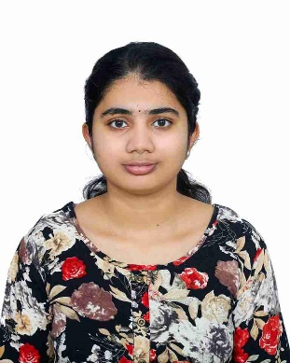
EeliRamyaSree
SRO0779240
Hyderabad
H

The Invisible Syllabus: What Books Don’t Teach Us About CA

When we signed up for the Chartered Accountancy course, we knew about the syllabus. We knew about Accounting Standards, Direct Taxes, and Corporate Laws. We bought the books, highlighted the key points, and prepared for the academic marathon.
But nobody handed us the "invisible syllabus"—the mental and emotional lessons that define this journey just as much as the technical ones.
The first lesson on this invisible syllabus is Resilience. There is a unique kind of stamina required to sit in the same chair for ten hours a day, months on end, while the rest of the world seems to be on vacation. It’s the ability to look at a vast syllabus, feel overwhelmed, and then open the book anyway.
The second lesson is Handling Failure. In school, many of us were top performers. CA is often the first place we taste rejection or don't get the desired results despite hard work. Learning that an attempt is not a definition of our worth, but rather a stepping stone, is perhaps the hardest subject to master.
Finally, there is the lesson of Sacrifice. We trade festivals for revision classes and weekends for mock tests. It feels heavy in the moment, but it teaches us the value of delayed gratification—a trait essential for any successful professional.
While we chase exemption marks and attempt to conquer the vast technical material, let’s not forget to give ourselves credit for mastering the invisible syllabus. When we finally add those two letters before our names, it won’t just prove that we know the law; it will prove that we have the character, discipline, and resilience to be leaders.
Keep going. The view is worth the climb.

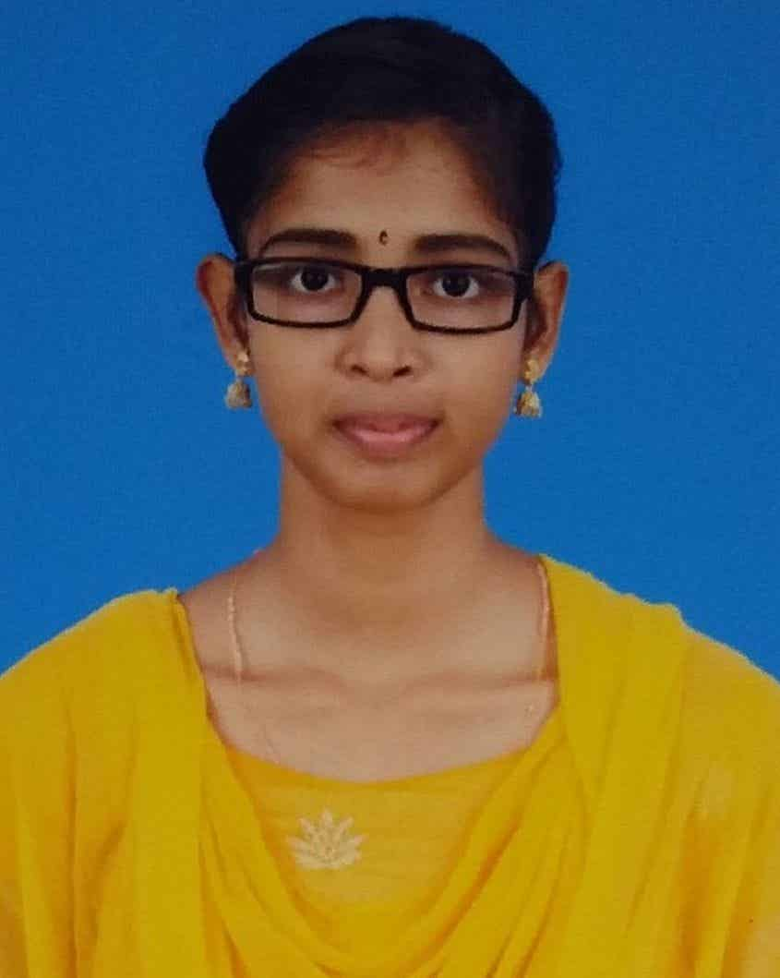
Jaya Sicily T
SRO0825041
Thiruvallur
H

CREATIVE BUNCH
PAINTINGS-I
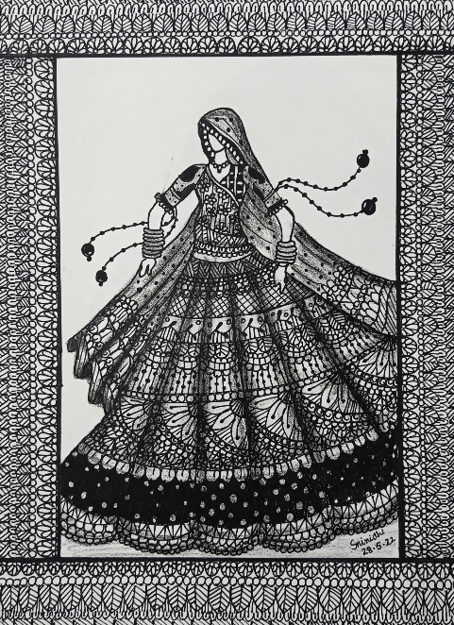
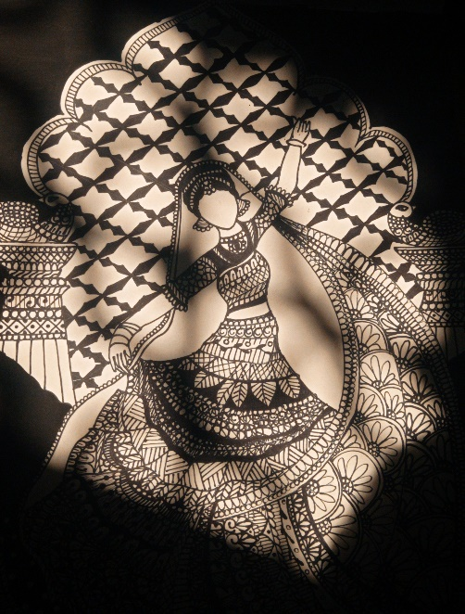

ManchalaSrinidhi
SRO0848901
Hyderabad

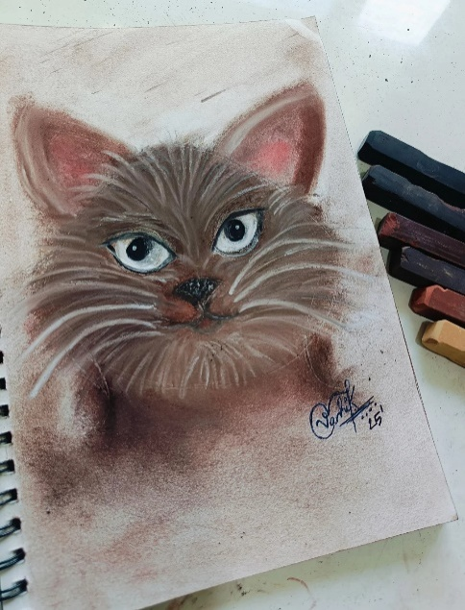
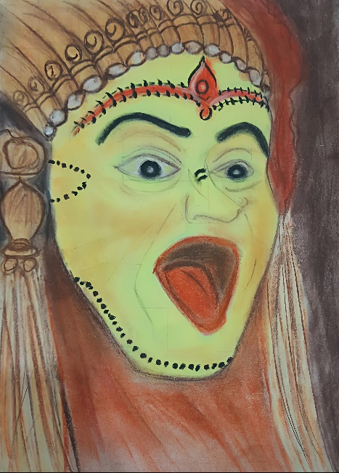
VanhishikaKhandavilli
SRO0862546
HYDERABAD

POEM
THE COUNT

She once counted the number of years for her to wait till boards so that she could step into CA.
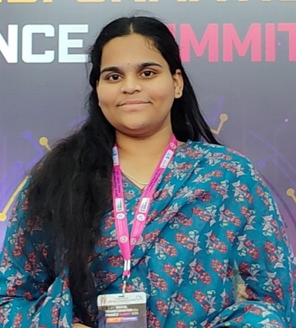
She counted the days left until her first CA Foundation exam,
and the moments leading to the real challenge of CA Inter.

She then counted the implications of giving one group or both in CA Inter.
But once the results arrived,
she counted the mistakes she had made,
the extra attempts she now faced,
and the years quietly adding to her age.

She counted her weaknesses,
then her strengths,
and the applications and interviews
SushmaSree Nuka
SRO0796106
Hyderabad
H
She tackled for her CA articleship.

She counted the hours of sleep she lost,
and the hours she could spare for CA Final classes while working.
When practical training ended,
she counted the months left to lock in her final prep,
the pending revisions,
and the mistakes from CA Inter; she vowed not to repeat.

This time, she counts her final exam marks with confidence.
And finally, all her internal counting comes to an end
when the actual marks appear before her eyes with the words: “Successful.”

Although becoming a member opens a whole new spectrum of counting,
let’s pause to celebrate the journey she’s counted through—
the one that finally answers the dreams
of that 16-year-old girl who longed to be a CA.

In a course built on numbers, counting can never be separated from its roots.
But all those counts, worries, and hopes
find their worth in one unquantifiable moment—
When the word “Successful” graces her marksheet.

The Lady Who Created Us
She's a simple girl....
I use the word 'girl' because the girl she wanted to become was left alone.
The girl she is now is nowhere near her personality.
She killed her. She killed herself with her own two eyes and her own two hands.
She once wished at the age of 6,
that her groom would come from Madras;
The almighty said so be it.

She once wished that her and her sister's lives would be at peace if she worked hard and studied.
The almighty said so be it on the 'hard work' part.

She used to leave for the cotton separation factory early 6 in the morning, eat puffed rice and sleep alone.

She wished the lord to break her from this loop
And the almighty got her married off.

She once in her life wished for love from her husband.
Only to find out how betrayed our father already was and how unwilling and unlikely to be her husband made my parents feel...,
They were terrible!

They were terrible in terms of understanding love and having a connection with.,
But those were days when;
These two were the only hope in one's life
My father was not at all strong physically,
My mother was not at all strong mentally,
which ...exchanged when exactly what was needed

Idon't know why a man doesn't trust his woman...
idont realise how heart wrenching it is to live with a man who doesn't trust or respect you just because other woman broke his faith

this duo coming right into my life after my sister was born....was not easy.

every one ever wondered if "HE" would have kids let alone having two "DAUGHTERS".

HE CHANGED

my father ...he changed!!
.......
• the sister was his pride and
• the younger one was his transperant self
the life he gave us in the toughest made us strong

coming back to the girl he married was now in pain
trauma driven and even the responsibility of motherhood was a new life.
she was bloody not only selfless but resilient...
coming from another state, she learned the language and taught her daughters tooo.

after the thick and thin of 22 years

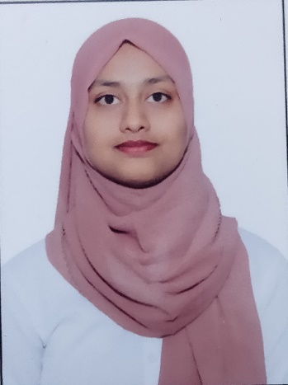
she lost Him for good

there's nothing much to describe how why where and what has happened

but the scene left a mark in the family's heart and soul which couldn't be erased...

the girl he married is now a widow
the girl she was is a mother of two
the girl she was a never ending saga
the girl she wanted to become was engulfed in responsibility which almost choke her every damn day
the version of her being girl who would be really happy was never coming home....
SHEEBA SHAZIYA SRO0789361
Hyderabad
H

INVITATION FOR ARTICLE

SICASA Hyderabad is inviting articles for the E-Newsletter: INSIGHT for the month of July 2024. All the students who want to get featured can submit their articles, artworks, poems, and short stories, etc., which are related to the Chartered Accountancy curriculum, for our future newsletters. You can also play Quiz&Puzzles.
Send us your works on:sicasahydnewsletter@gmail.com

Last Date for Submission:10thOctober, 2025.

Rules:
- No word limit, but the articles shall be confined to the topic opted for.
- The article should be sent in a Word document only.
3. No plagiarism allowed; content sent should be original.
4. Send your works to the mail with the following attachments:
- Your work
- Full name along with student registration number & firm name
- Passport photo
- Contact details.
- Subject of email must contain the details of your work
(E.g., Article/Artwork, etc.)

